**INSPIRE**

**Infrastructure for Spatial Information in Europe**

Best Practices for registers and registries & Technical Guidelines for the INSPIRE register federation

|  |  |
| --- | --- |
| **Title** | Best Practices for registers and registries & Technical Guidelines for the INSPIRE register federation |
| **Creator** | JRC registry team |
| **Date of last update** | 2016-10-04 |
| **Subject** | Best Practices for registers and registries & Technical Guidelines for the INSPIRE register federation |
| **Status** | Version 1.0rc3 |
| **Publisher** | MIG-T |
| **Type** | Text |
| **Description** | This document describes best practices for setting up registers for INSPIRE, including for extended INSPIRE code lists. It also includes technical guidance for sharing national or community registers in the INSPIRE register federation and for using the federation’s access point (the “register of registers”) to search and browse through the registers included in the federation. |
| **Format** | MS Word (doc) |
| **Source** | MIG-T sub-group MIWP-6 on registers and registries |
| **Rights** | Reuse is authorised, provided the source is acknowledged. The reuse policy of the European Commission is implemented by a [Decision of 12 December 2011](http://eur-lex.europa.eu/legal-content/EN/TXT/?uri=CELEX:32011D0833). |
| **Identifier** |  |
| **Language** | EN |

**Table of Contents**

Foreword 5

Executive Summary 6

1 Introduction 7

2 Normative references 9

3 Terms and abbreviations 10

3.1 Terms 10

3.2 Symbols and abbreviations 10

3.3 Verbal forms for the expression of provisions 11

3.4 References 12

4 Registers and registries 13

4.1 INSPIRE requirements for code lists and code list extensions 13

4.2 Best practices for setting up registers and registries 14

4.2.1 Best Practice 1: Well defined roles, responsibilities and procedures for register management 15

4.2.2 Best Practice 2: Use resolvable URIs as identifiers for registers and register items 16

4.2.3 Best Practice 3: Use item classes 16

4.2.4 Best Practice 4: Use well-defined statuses 17

4.2.5 Best Practice 5: Do not delete items 18

4.2.6 Best Practice 6: Provide registers in different formats 19

4.2.7 Best Practice 7: Use content negotiation for serving registers available in multiple formats 19

4.2.8 Best Practice 8: Provide registers in different languages 20

4.3 Register reuse (extensions, sub-sets and profiles) 20

4.3.1 Harvesting scenario 22

4.3.2 Reference scenario 22

5 The INSPIRE register federation 23

5.1 Why a register federation? 23

5.2 Architecture and interactions 23

5.3 RoR data model 25

6 How to join the INSPIRE Register Federation 28

6.1 Core conformance class 28

6.1.1 Registry descriptor 29

6.1.2 Register descriptor 31

6.2 Automatic harvesting conformance class 33

6.2.1 Registry descriptor 33

6.2.2 Register descriptor 33

6.3 Content conformance class 34

6.3.1 Registry descriptor 34

6.3.2 Register descriptor 34

6.4 Validating the descriptors 36

6.5 Registering descriptors in the RoR 37

7 How to use the INSPIRE Register Federation 39

7.1 Browsing the federation content 39

7.1.1 Registries 39

7.1.2 Registers 40

7.1.3 Relations 41

7.2 Searching for content in the federation 42

7.3 API interface 42

Annex A Example descriptors 43

A.1 Core conformance class 43

A.1.1 Registry descriptor 43

A.1.2 Register descriptor 44

A.2 Automatic harvesting conformance class 45

A.2.1 Registry descriptor 45

A.2.2 Register descriptor 47

A.3 Content conformance class 48

A.3.1 Registry descriptor 48

A.3.2 Register descriptor 50

Annex B Descriptor Validators 53

Annex C Using extended code lists when sharing INSPIRE data 55

Annex D Registry information systems: available implementations 56

**Table of figures**

Figure 1 - Example for a hierarchical register 12

Figure 2 - UKgovLD status schema 17

*Figure 3 – Different types of register profiles. The original register is shown in light blue, the register profile in dark blue*. 20

Figure 4 - RoR architecture – information retrieval and indexing 22

Figure 5 - RoR architecture – browsing and search 23

Figure 6 - Simplified RoR data model 24

Figure 7 - INSPIRE Register Federation administration page: adding a new registry descriptor 35

Figure 8 - Manual Harvesting start (red) & Report check (yellow highlight) 35

Figure 9 - Harvesting report dialog - Validation success 36

Figure 10 - Example of the INSPIRE Register Federation browsing interface: Registries 37

Figure 11 - Example of Registry details page 38

Figure 12 - Example of Register details page 39

Figure 13 - Example of Relation register 40

Figure 14 - Example of search interface 40

Figure 15 - Example of validator output 52

# Foreword

**Directive 2007/2/EC** of the European Parliament and of the Council [**INS DIR**], adopted on 14 March 2007 aims at establishing an **Infrastructure for Spatial Information in the European Community** (INSPIRE) for environmental policies, or policies and activities that have an impact on the environment. INSPIRE will make available relevant, harmonised and quality geographic information to support the formulation, implementation, monitoring and evaluation of policies and activities, which have a direct or indirect impact on the environment.

INSPIRE is based on the infrastructures for spatial information established and operated by the 28 Member States of the European Union. The Directive addresses **34 spatial data themes** needed for environmental applications. This makes INSPIRE a unique example of a legislative “regional” approach.

To ensure that the spatial data infrastructures of the Member States are compatible and usable in a Community and trans-boundary context, the Directive requires that common **Implementing Rules** (IR) be adopted in the following areas.

* Metadata;
* The interoperability and harmonisation of spatial data and services for selected themes (as described in Annexes I, II, III of the Directive);
* Network Services;
* Measures on sharing spatial data and services;
* Co-ordination and monitoring measures.

The Implementing Rules are adopted as Commission Decisions or Regulations, and are legally binding in their entirety.

In addition to the Implementing Rules, non-binding **Technical Guidance** documents describe detailed implementation aspects and relations with existing standards, technologies, and practices. Technical Guidance documents define **how Member States might implement the Implementing Rules** described in a Commission Regulation **or other aspects** (not required by the Implementing Rules) **that will improved interoperability in the INSPIRE infrastructure**. These documents may include non-binding technical requirements that must be satisfied in order for an implementer to claim conformance with the Technical Guidance.

This document describes **best practices for setting up registers for INSPIRE**, including for extended INSPIRE code lists. It also includes **technical guidance for sharing national or community registers in the INSPIRE register federation** and for using the federation’s access point (the “register of registers”) to search and browse through the registers included in the federation.

Note that there are no requirements in the INSPIRE implementing rules for setting up a register federation or for registry/register managers to join it. Therefore the **compliance with the requirements in this document is entirely voluntary.**

|  |
| --- |
| **Disclaimer**  This document has been developed collaboratively through the INSPIRE maintenance and implementation framework, involving the European Commission, European Environment Agency, EU Member States, the Accession and EFTA Countries. The document should be regarded as presenting an informal consensus position on best practice agreed by all partners. However, the document does not necessarily represent the official, formal position of any of the partners. Hence, the views expressed in the document do not necessarily represent the views of the European Commission. |

# Executive Summary

*Registers* provide a means to assign unique identifiers (or “reference codes”) to and consistently manage different versions of resources used in the INSPIRE infrastructure, such as INSPIRE code lists, INSPIRE themes, coordinate reference systems or application schemas. *Registries* are information systems for the maintenance and publication of registers.

INSPIRE includes only one legal obligation related to registers: extensions by data providers of the code lists mandated in Commission Regulation (EU) No 1089/2010 on interoperability of spatial data sets and services need to be published in registers. This document provides technical guidance for setting up such registers for extended INSPIRE code lists.

However, Member States and thematic communities are setting up registers for other purposes as well, e.g. to have a single repository of all organisations in a MS responsible for implementing INSPIRE, including their unique identifiers. In general, registers are useful in all situations where, by a reference code rather than free text, in data exchange, ambiguities or inconsistencies can be avoided. Also registers can facilitate the internationalisation of user interfaces by providing multilingual labels.

Therefore, this document also includes general guidance and best practices for setting up registers supporting INSPIRE implementation and for sharing the content of national or community registers in a *register federation* and for using the federation’s access point (the “register of registers”) to search and browse through the registers included in the federation.

This document is based on the work of the sub-group MIWP-6 on registers and registries of the maintenance and implementation group in 2015 and 2016.

# Introduction

*Registers* provide a means to assign unique identifiers (or “reference codes”) to and consistently manage different versions of resources used in the INSPIRE infrastructure, such as INSPIRE code lists, INSPIRE themes, coordinate reference systems or application schemas. *Registries* are information systems for the maintenance and publication of registers.

Managing and making available items in registers offers several benefits [adapted from ISO 19135-1]:

1. Registration of items supports wider use of registered items by making them publicly available to INSPIRE users.
2. Registers may provide a single mechanism to access information concerning items that are specified or used in different INSPIRE components.
3. Registers provide a mechanism for managing temporal change (of available items of a certain type and their definitions).

NOTE Items specified in a register may change over time either due to changes in technology or for other reasons. INSPIRE documents may not clearly document what changes may have occurred, and do not include information about earlier versions of specified items. Such information can be maintained in a register.

1. Registers may be used to make sets of standardized tags available for encoding of registered items in data sets.
2. Registers can support cultural and linguistic adaptability by providing both a means for recording equivalent names of items used in different languages, cultures, application areas and professions, and a means for making those equivalent names publicly available.

INSPIRE includes only one legal obligation related to registers: extensions by data providers of the code lists mandated in Commission Regulation (EU) No 1089/2010 on interoperability of spatial data sets and services need to be published in registers [**INS ISDSS**, Art.6(2)]. INSPIRE implementers need technical guidance on how to set up such registers for extended INSPIRE code lists and how these can be linked to the central INSPIRE code list register.

At the same time, Member States and thematic communities are setting up registers for other purposes as well, e.g. to have a single repository of all organisations in a MS responsible for implementing INSPIRE, including their unique identifiers. In general, registers are useful in all situations where, by a reference code rather than free text, in data exchange, ambiguities or inconsistencies can be avoided. Also registers can facilitate the internationalisation of user interfaces by providing multilingual labels.

Within the MIWP 2014-2016, an action and sub-group[1] (MIWP-6) was therefore set up to develop technical guidelines and best practices for setting up register and registries and how European, national or community registers and the links between them can be published in and accessed through a *register federation*. The action also worked on setting up an access point to the INSPIRE register federation, the *register of registers* (RoR).

Based on the work of the MIWP-6 sub-group, this document contains

* best practices for setting up registers supporting INSPIRE implementation (section 4.2);
* best practices for setting up registers for extended INSPIRE code lists and how to link them to the central INSPIRE code list register (section 4.3);
* a description of the concept and architecture of the INSPIRE register federation and the register of registers (section 5);
* guidance for sharing the content of national or community registers in the INSPIRE register federation (section 6);
* guidance for using the register of registers to search and browse through the registers included in the federation (section 7).

It also includes several annexes with detailed examples (Annex A), validation scripts (Annex B), frequently asked questions (Annex C) and an overview of existing software for registry management (Annex D).

Items for future work on this document include:

* Documentation of the API of the RoR
* Support for multi-lingual registers in the RoR harvesting

# Normative references

The following referenced documents are indispensable for the application of this document. For dated references, only the edition cited applies. For undated references, the latest edition of the referenced document (including any amendments) applies.

**DCAT** Fadi Maali; John Erickson. W3C. Data Catalog Vocabulary (DCAT). 16 January 2014. W3C Recommendation. URL: <https://www.w3.org/TR/vocab-dcat/>

**INS DIR** Directive 2007/2/EC of the European Parliament and of the Council of 14 March 2007 establishing an Infrastructure for Spatial Information in the European Community (INSPIRE), OJ L 108, 24.4.2007, p. 1

I**NS ISDSS** Commission Regulation (EU) No 1089/2010 of 23 November 2010 Implementing Directive 2007/2/EC of the European Parliament and of the Council as regards interoperability of spatial data sets and services as amended by Commission Regulation (EU) No 1312/2014 of 10 December 2014, OJ L 354, 11.12.2014, p. 8–16

**ISO 19106** ISO 19106:2004, Geographic information – Profiles. URL: <http://www.iso.org/iso/home/store/catalogue_tc/catalogue_detail.htm?csnumber=26011>

**ISO 19115-1** ISO 19115-1:2014, Geographic information – Metadata – Part 1: Fundamentals. URL: <http://www.iso.org/iso/home/store/catalogue_ics/catalogue_detail_ics.htm?csnumber=53798>

**ISO 19135-1** ISO 19135-1:2015, Geographic information – Procedures for item registration – Part 1: Fundamentals. URL:  
<http://www.iso.org/iso/home/store/catalogue_ics/catalogue_detail_ics.htm?csnumber=54721>

**ISO 19157** ISO 19157:2013, Geographic information – Data quality. URL: <http://www.iso.org/iso/iso_catalogue/catalogue_tc/catalogue_detail.htm?csnumber=32575>

**SKOS** Alistair Miles; Sean Bechhofer. W3C. SKOS Simple Knowledge Organization System Reference. 18 August 2009. W3C Recommendation. URL: <http://www.w3.org/TR/skos-reference>

**W3C DWBP** Bernadette Farias Lóscio; Caroline Burle; Newton Calegari. W3C. Data on the Web Best Practices. 19 May 2016. W3C Editor’s Draft. URL: <https://www.w3.org/TR/dwbp/>

**PURI** D7.1.3 Study on persistent URIs, with identification of best practices and recommendations on the topic for the MSs and the EC. URL: <https://joinup.ec.europa.eu/sites/default/files/c0/7d/10/D7.1.3%20-%20Study%20on%20persistent%20URIs.pdf>

**INS REG** INSPIRE registry service. URL: <http://inspire.ec.europa.eu/registry>

# Terms and abbreviations

## Terms

1. **code list:** open enumeration that can be extended [**INS-ISDSS**]
2. **enumeration:** data type whose instances form a fixed list of named literal values. Attributes of an enumerated type may only take values from this list [**INS-ISDSS**]
3. **item**: anything that can be described and considered seperately [**ISO 19157**]

NOTE An item can be any part of a dataset, such as a feature, feature relationship, feature attribute, or combination of these.

1. **item class**: set of items with common properties [**ISO 19135-1**]

NOTE Class is used in this context to refer to a set of instances, not the concept abstracted from that set of instances.

1. **metadata:** information describing spatial data sets and spatial data services and making it possible to discover, inventory and use them [**INS DIR**]

NOTE A more general definition provided by [**ISO 19115-1**] is "data about data"

1. **multilingual:** in or using several languages [Oxford Dictionary]
2. **register:** set of files containing identifiers assigned to items with descriptions of the associated items [**ISO 19135-1**]
3. **registry:** information system on which a register is maintained [**ISO 19135-1**]
4. **registry service**: Service that provides access to a register
5. **resource**: asset or means that fulfils a requirement [**ISO 19115-1**]

NOTE A resource can be anything that has identity. In the context of the web as the network of INSPIRE, a resource will be identified by a URI. For resources managed in INSPIRE registers, the URIs will be persistent and dereferenceable. Dereferencing of the URI will return a representation of the resource in a well-known representation.

EXAMPLE: Dataset, service, document, person or organization. …

## Symbols and abbreviations

|  |  |
| --- | --- |
| ISDSS | Interoperability of spatial data sets and services |
| ISO | International Organization for Standardization[2] |
| MD | Metadata |
| MS | Member state |
| RoR | Register of Registers |
| SKOS | Simple Knowledge Organization System |
| URL | Uniform Resource Locator |
| XSD | XML Schema Definition |

## Verbal forms for the expression of provisions

In accordance with the ISO rules for drafting, the following verbal forms shall be interpreted in the given way:

* “shall” / “shall not”: a requirement, mandatory to comply with the technical guidance
* “should” / “should not”: a recommendation, but an alternative approach may be chosen for a specific case if there are reasons to do so
* “may” / “need not”: a permission

**Technical Guidance Conformance Classes notation**

The Technical Guidance in this document is divided into Conformance Classes, so that it is possible to declare conformance to specific parts of the Technical Guidance. *To conform to a Conformance Class it is necessary to meet all of the Requirements (see next section) in that Conformance Class.*

Conformance Classes are identified in the document as follows:

TG Conformance Class #: [TITLE] conformance classes are shown using this style

**Technical Guidance Requirements and Recommendations notation**

Requirements and the recommendations within this technical guidance are highlighted and numbered as shown below:

TG Requirement # requirements are shown using this style

**TG Recommendation #** recommendations are shown using this style.

Requirements and recommendations belong to the conformance class in which they are found in this document.

**Note**: It is worth noting that requirements as specified in the INSPIRE Regulations and Implementing Rules are legally binding, and that requirements and recommendations as specified in INSPIRE Technical Guidance are **not** legally binding. Therefore, within this technical guidance we have used the terms ‘TG requirement’ and ‘TG recommendation’ to indicate what is technically required or recommended to conform to the Technical Guidance.

**XML Example notation**

XML Examples are shown using Courier New on a grey background with yellow for emphasis as below:

<inspire:example>

<inspire:highlight>

Highlighted Text for emphasis

</inspire:highlight>

</inspire:example>

**Note**: XML Examples are informative and are provided for information only and are expressly not normative.

## References

References within this document are denoted using “Section” or “Annex”. For example, Section 5.3.1 or Annex A.

References to other documents refer to the list of normative references in Section 2 and use the abbreviated title as indicated in **Bold** text. For example, [**INS DIR**] uses the abbreviated title for the document as shown below:

Directive 2007/2/EC of the European Parliament and of the Council of 14 March 2007 establishing an Infrastructure for Spatial Information in the European Community (INSPIRE), OJ L 108, 24.4.2007, p. 1

References within other documents are shown as above using the reference code, together with the appropriate section within the document. For example, [**INS DIR,** Art 1 (1)], refers to Article 1.1 within the document as listed above.

# Registers and registries

Registries and registers are used to maintain information elements at different administrative levels (e.g. European, national level) and in different thematic domains or contexts.

A registry is an information system on which registers are maintained [**ISO 19135-1**]. A registry can be set up as a central access point where labels, descriptions and other metadata for reference codes can be easily maintained, checked by humans or retrieved by machines.

A register is a set of files containing identifiers assigned to items with descriptions of the associated items [**ISO 19135-1**]. Registration is the assignment of an unambiguous name to an object in a way that makes the assignment available to interested parties.

Register can be hierarchical. A hierarchical register is a structured set of registers composed of a principal register and one or more sub-registers.

EXAMPLE The INSPIRE code list register is a hierarchical register, which contains code lists as its items, which in turn contain code list values as their items.

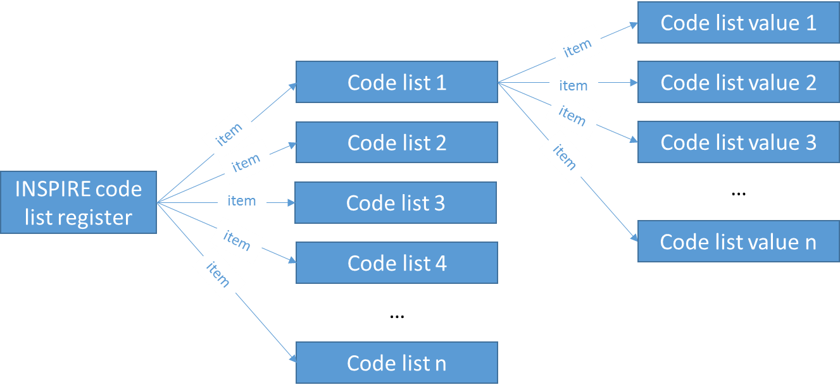

Figure 1 - Example for a hierarchical register

## INSPIRE requirements for code lists and code list extensions

[**INS ISDSS**] includes the following requirements related to code lists and their possible extensions by data providers.

|  |
| --- |
| *Article 6*  **Code Lists and Enumerations**   1. Code lists shall be of one of the following types, as specified in the Annexes:    1. code lists whose allowed values comprise only the values specified in this Regulation;    2. code lists whose allowed values comprise the values specified in this Regulation and narrower values defined by data providers;    3. code lists whose allowed values comprise the values specified in this Regulation and additional values at any level defined by data providers;    4. code lists, whose allowed values comprise any values defined by data providers. 2. For the purposes of points (b), (c) and (d), in addition to the allowed values, data providers may use the values specified in the relevant INSPIRE Technical Guidance document available on the INSPIRE web site of the Joint Research Centre. 3. Code lists may be hierarchical. Values of hierarchical code lists may have a more general parent value. Where the valid values of a hierarchical code list are specified in a table in this Regulation, the parent values are listed in the last column. 4. Where, for an attribute whose type is a code list as referred to in points (b), (c) or (d) of paragraph 1, a data provider provides a value that is not specified in this Regulation, that value and its definition shall be made available in a register. 5. Attributes or association roles of spatial object types or data types whose type is a code list may only take values that are allowed according to the specification of the code list. 6. Attributes or association roles of spatial object types or data types that have an enumeration type may only take values from the lists specified for the enumeration type. |

Art. 6(4) is the only requirement on INSPIRE data providers to publish data in a register. No further requirements are included in [**INS ISDSS**]. The following section contains a number of best practices for setting up registers – for code lists or other item classes.

## Best practices for setting up registers and registries

While based on the definition of a register from [**ISO 19135-1**], a basic register could already be created through a simply document (e.g. a text document or spreadsheet) that contains a list of items, each of which is mapped to an identifier.

In this section, we add a number of best practices for the setting up and operation of registers that make them more useful in the context of a distributed spatial data infrastructure such as INSPIRE. Most of these recommendations are valid for any data being published on the web. The W3C Data on the Web Best Practices document[3] [**W3C DWBP].** Where relevant, we therefore include references to the corresponding best practices in this document.

Typically, software packages or online services will be used for managing registers according to these guidelines / best practices. Some examples are listed in Annex D.

NOTE To our knowledge, there is currently no centralised service at European level that can be used for managing MS registers.

The following list present some best practices to follow in order to create/maintain registers/registries:

Best Practice 1: Well defined roles, responsibilities and procedures for register management

Best Practice 2: Use resolvable URIs as identifiers for registers and register items

Best Practice 3: Use item classes

Best Practice 4: Use well-defined statuses

Best Practice 5: Do not delete items

Best Practice 6: Provide registers in different formats

Best Practice 7: Use content negotiation for serving registers available in multiple formats

Best Practice 8: Provide registers in different languages

### Best Practice 1: Well defined roles, responsibilities and procedures for register management

|  |
| --- |
| Clearly document roles, responsibilities and procedures for the management of a register and the registry through which it is made available.  **Why**  Having a set of roles and associated responsibilities helps to better understand the different parties involved in the registration and maintenance processes of a registry system.  **Intended Outcome**  Register users will be able to understand who is responsible for managing a register and the registry through which it is made available and the processes for proposing and deciding about changes to register content.  **Possible Approach to Implementation**  The following roles and responsibilities are defined in [**ISO 19135-1**]. For more detailed information refer to [**ISO 19135-1**] Chapter 5.   * **Register owner**: a register owner is an organization that has established one or more registers, and has primary responsibility for the management, dissemination and intellectual content of those registers. * **Register manager**: a register owner may delegate the role of register manager to another organization. A register manager may manage multiple registers. * **Submitting organizations**: a submitting organization is an organization that is qualified under criteria determined by the register owner to propose changes to the content of a register. * **Control body**: a control body is a group of technical experts appointed by a register owner to decide on the acceptability of proposals for changes to the content of a register. Control body may not be required for simple registers. * **Registry manager**: a registry manager is a person or an organization responsible for the day-to-day management of a registry. A register manager may engage a third-party service provider to perform this service. * **Register user**: Register users access a registry in order to use one or more of the registers held in that registry. Register users include any person or organization interested in accessing or influencing the content of a register.   A possible list of procedures to manage the registration and maintenance process can be found in chapter 6 of [**ISO 19135-1**].  **Example**  An example of roles can be seen in the central INSPIRE registry[4].  *Owner:* European Union  *Register manager:* European Commission, Joint Research Centre  *Control body:* INSPIRE Maintenance and Implementation Group (MIG)  *Submitter:* Members of INSPIRE Maintenance and Implementation Group (MIG)  *Contact point:* JRC INSPIRE Registry Team |

### Best Practice 2: Use resolvable URIs as identifiers for registers and register items

|  |
| --- |
| Identify each register and register item by a carefully chosen, persistent and resolvable URI.  **Why**  Adopting a common identification system enables basic data identification and comparison processes by any stakeholder in a reliable way. They are an essential pre-condition for proper data management and reuse.  Developers may build URIs into their code and so it is important that those URIs persist and that they dereference to the same resource over time without the need for human intervention.  **Intended Outcome**  Registers and register items can be consistently referenced through time, regardless of the status, availability or format of the registers and register items.  **Possible Approach to Implementation**  To be persistent, URIs must be designed as such. A lot has been written on this topic, see, for example, the European Commission's Study on Persistent URIs [**PURI**] which in turn links to many other resources.  Where a data publisher is unable or unwilling to manage a URI space directly for persistence, an alternative approach is to use a redirection service such as Permanent Identifiers for the Web or purl.org. These provide persistent URIs that can be redirected as required so that the eventual location can be ephemeral. The software behind such services is freely available so that it can be installed and managed locally if required.  Digital Object Identifiers (DOIs) offer a similar alternative. These identifiers are defined independently of any Web technology but can be appended to a 'URI stub.' DOIs are an important part of the digital infrastructure for research data and libraries.  **Example**  The INSPIRE themes register is identified by the following http URI: <http://inspire.ec.europa.eu/theme>  The register item “Administrative Units” in the theme register is identified by the following http URI: <http://inspire.ec.europa.eu/theme/au>  **See also**   * [Best Practice 10](https://www.w3.org/TR/dwbp/#UniqueIdentifiers): Use persistent URIs as identifiers of datasets [**W3C DWBP**] * [Best Practice 11](https://www.w3.org/TR/dwbp/#identifiersWithinDatasets): Use persistent URIs as identifiers within datasets [**W3C DWBP**] |

### Best Practice 3: Use item classes

|  |
| --- |
| Organize the different elements contained in a registry using item classes: an item class is a set of items with common properties.  **Why**  Defining an item class, helps creating groups of items with the same set of properties. A register could contain items with different set of properties (e.g. the INSPIRE code list register contains code lists and code list values which have different properties). Organizing the items contained inside the same register in item classes helps keeping items with the same set of properties grouped. In this way the item type can be easily distinguished inside a register.  **Intended Outcome**  Items with the same set of properties are organized under the same item class inside a register.  **Possible Approach to Implementation**  For each register, identify the group of items having the same set of properties. Each of this group is an item class. The item class can also contain a hierarchy.  **Example**  The hierarchical INSPIRE code list register contains two item classes, each with its own specific attributes:   * Code list (containing e.g. information about the extensibility) * Code list value |

### Best Practice 4: Use well-defined statuses

|  |
| --- |
| Define a list of statuses for the elements: items shall be individually managed, moving through a set of well-defined states.  **Why**  Items inside a register can change over time. These changes may include simple modifications, bigger changes involving semantic modifications or even the supersession by other item(s), the retirement or the end of the validity of a specific item.  Keeping the status of the item helps understanding its validity.  **Intended Outcome**  Register users can understand the status of each register item, e.g. whether it is valid (i.e. can be used), proposed (i.e. should be used with caution), deprecated or superseded (i.e. should no longer be used).  **Possible Approach to Implementation**  Add to the items a field to specify the status. The status should be an URI pointing to the defined status register.  **Example**  The central INSPIRE registry[5] uses the following status values:   * submitted: The item has been entered into the register, but the control body has not accepted the proposal to add it. * valid: The item has been accepted, is recommended for use, and has not been superseded or retired. * invalid: A decision has been made that a previously valid register item contains a substantial error and is invalid, and will normally have been replaced by a corrected item. * retired: A decision has been made that the item is no longer recommended for use. It has not been superseded by another item. * superseded: The item has been superseded by another item and is no longer recommended for use.   The UKGovLD registry[6] proposes the following hierarchical list of status values:   * notAccepted – corresponds to ISO 19135:2005 'notValid'   + submitted – corresponds to ISO 19135:(draft) 'submitted'   + reserved – flags a reserved entry, same semantics as submitted   + invalid – corresponds to ISO 19135:(draft) 'invalid' * accepted   + valid – corresponds to ISO 19135:2005 'valid'     - experimental - the item is being trialed and might be withdrawn or replaced     - stable – no change is currently anticipated   + deprecated     - superseded – corresponds to ISO 19135:2005 'superseded'     - retired – corresponds to ISO 19135:2005 'retired'     Figure 2 - UKgovLD status schema |

### Best Practice 5: Do not delete items

|  |
| --- |
| Once the elements enter in a registry/register, they shall not be deleted in order to maintain the consistency of the registry. Instead of deleting items, a status that states the element as retired or invalidated shall be used.  **Why**  URI dereferencing is the primary interface to data on the Web. If dereferencing a URI leads to the infamous 404 response code (Not Found), the user will not know whether the lack of availability is permanent or temporary, planned or accidental. If the publisher, or a third party, has archived the data, that archived copy is much less likely to be found if the original URI is effectively broken.  **Intended Outcome**  The URI of an element inside a registry system will always dereference to the element or redirect to information about it.  **Possible Approach to Implementation**  Instead of deleting items, a status that states the element as retired or invalidated shall be used.  **Example**  An example item which is no longer valid but still have a resolvable URI is the “Gazetteer” (<http://inspire.ec.europa.eu/featureconcept/Gazetteer>) item in the INSPIRE feature concept dictionary.  **See also**   * [Best Practice 27](https://www.w3.org/TR/dwbp/#ResourceStatus): Preserve identifiers [**W3C DWBP**] |

### Best Practice 6: Provide registers in different formats

|  |
| --- |
| Make registers available in multiple formats. HTML should be provided human consumption and at least one machine readable format should be provided in order to enable programmatic access and exchange of information. Machine-readable formats should re-used existing standard vocabularies, e.g. SKOS Simple Knowledge Organization System [**SKOS**] or the Data Catalog Vocabulary (DCAT) [**DCAT**].  **Why**  Providing data in more than one format reduces costs incurred in data transformation. It also minimizes the possibility of introducing errors in the process of transformation. If many users need to transform the data into a specific data format, publishing the data in that format from the beginning saves time and money and prevents errors many times over. Lastly it increases the number of tools and applications that can process the data.  **Intended Outcome**  As many users as possible will be able to use the register content without first having to transform it into their preferred format.  **Possible Approach to Implementation**  Consider the data formats most likely to be needed and consider alternatives that are likely to be useful in the future. Data publishers must balance the effort required to make the data available in many formats against the cost of not doing so, but providing at least one alternative will greatly increase the usability of the data. In order to serve data in more than one format you can use content negotiation as described in Best Practice 7.  **Example**  The central INSPIRE registry provides register in multiple formats, including (custom and ISO 19135) XML, RDF/XML, JSON, ATOM and CSV.  **See also**   * [Best Practice 14](https://www.w3.org/TR/dwbp/#MultipleFormats): Provide data in multiple formats [**W3C DWBP**] * [Best Practice 15](https://www.w3.org/TR/dwbp/#ReuseVocabularies): Reuse vocabularies, preferably standardized ones [**W3C DWBP**] |

### Best Practice 7: Use content negotiation for serving registers available in multiple formats

|  |
| --- |
| Use content negotiation in addition to file extensions for serving data available in multiple formats.  **Why**  It is possible to serve data in an HTML page mixed with human-readable and machine-readable data, using RDFa for example. However, as the Architecture of the Web[7] and DCAT [**DCAT**] make clear, a resource, such as a dataset, can have many representations. The same data might be available as JSON, XML, RDF, CSV and HTML. These multiple representations can be made available via and API but should be made available from the same URL using content negotiation to return the appropriate representation (what DCAT calls a distribution). Specific URIs can be used to identify individual representations of the data directly, by-passing content negotiation.  **Intended Outcome**  Content negotiation will enable different resources or different representations of the same resource to be served according to the request made by the client.  **Possible Approach to Implementation**  A possible approach to implementation is to configure the Web server to deal with content negotiation of the requested resource.  The specific format of the resource's representation can be accessed by the URI or by the Content-type of the HTTP Request.  **Example**  The central INSPIRE registry supports the content-negotiation. Different representations of the items can be served according to the specified content type of the HTTP Request.  The example below shows the call to the same resource with two different formats (XML and RDF/XML).  Accept: application/xml http://inspire.ec.europa.eu/theme/ad  Accept: application/rdf+xml http://inspire.ec.europa.eu/theme/ad  **See also**   * [Best Practice 19](https://www.w3.org/TR/dwbp/#Conneg): Use content negotiation for serving data available in multiple formats [**W3C DWBP**] |

### Best Practice 8: Provide registers in different languages

|  |
| --- |
| Provide registry and registers in all the languages that are available in the specific national context. In a European context, it may also be useful to provide the registry and register data in English.  **Why**  The availability of all the language used in a national context will increase the usability of the registry system. In addition, the availability of a commonly used language such as the English, will allow also foreign users to access the information available in the registry.  **Intended Outcome**  As many users as possible will be able to access the register content in their preferred language.  **Possible Approach to Implementation**  The registry system shall provide a mechanism to select the available languages and to provide the registry content in the selected language.  **Example**  The central INSPIRE registry is an example of registry system that provide the information in multiple languages. |

## Register reuse (extensions, sub-sets and profiles)

Items from one register can be reused in another register in order to support specific thematic, application or national requirements. We use the term profile[8] here for a register that contains additional items, a subset of items, or a combination of both or a register that reuses all items from the original register 1:1 (Figure 2).



*Figure 3 – Different types of register profiles. The original register is shown in light blue, the register profile in dark blue*.

When creating a profile, a dependency is created between the original register and the profile, since any changes to reused items occurring in the original register should also be reflected in the profile. Such a dependency is expressed using the voaf:reliesOn relationship in the register descriptor (see section 6.1.2).

In order to have a complete context of the elements available in the profile, it should include any re-used items from the original register and any new items defined in this register.

1. If register A is a profile of register B, register A should include all the items from register B that are reused in A, in addition to any new items defined in register A.

EXAMPLE If A is a simple sub-set of B, it simply contains all items from B that are to be reused in A. For example, the EIONET air quality reporting guidelines restrict the values to be used for the Media code list (<http://inspire.ec.europa.eu/codelist/MediaValue>) containing the values *air, biota, landscape, sediment, soil/ground, waste* and *water* to only the value *air*.

|  |  |  |  |  |  |  |  |  |  |
| --- | --- | --- | --- | --- | --- | --- | --- | --- | --- |
| |  | | --- | | air | | biota | | landscape | | sediment | | soil/ground | | waste | | water | | |  | | --- | | air | |
| Values in the original register <http://inspire.ec.europa.eu/codelist/MediaValue> | Value in the sub-set <http://dd.eionet.europa.eu/vocabulary/inspire/MediaValue> |

EXAMPLE If A is a simple extension of B, it contains all items from B plus additional items that are to be used in A. For example, the GeoSmartCities project has extended the INSPIRE Current Use code list (<http://inspire.ec.europa.eu/codelist/CurrentUseValue>), with narrower (more specific) values of building use (e.g. *postOffice* or *policeStation*) in their extended code list (<http://hub.geosmartcity.eu/registry/codelist/CurrentUseValue/>).

In order to follow TG Recommendation 1, there are 2 possible implementation scenarios described below.

### Harvesting scenario

In this scenario, the element coming from the extended register are repeated in the new register by regularly harvesting them and storing them in the new register.

**Pro**: all the information of the original items is available in the new register, without the need to go to the original register to get them.

**Cons**: if the information contained in the original register changes, the data stored in the new register are inconsistent: the harvesting job should be frequent enough to ensure consistency.

### Reference scenario

In this scenario, the element coming from the extended register are just listed as a reference to the original register (e.g. a URI with the link to the item in the original register).

**Pro**: the information are always up to date, no need of harvesting procedure.

**Cons**: the new register will not contain any details of the referenced item (e.g. no label, no description); the only element available and visible is the URI.

# The INSPIRE register federation

The INSPIRE register federation is a distributed federation of registers related to the INSPIRE Directive.

The European Commission is operating a central registry providing common INSPIRE registers [**INS REG**], e.g. to manage INSPIRE code lists or themes. Where Member States extend these code lists, they are obliged to make available the extended values in local registers (see section 4.1). Such local registers can also support other use cases, e.g. the management of organisations in a country that have to implement INSPIRE, or thematic vocabularies, such as those provided by EU institutions and bodies.

In general, registers are useful in all situations where, by a reference code rather than free text, in data exchange, ambiguities or inconsistencies can be avoided. Also registers can facilitate the internationalisation of user interfaces by providing multilingual labels.

One of the aims of the MIWP-6 sub-group (MIWP-6) was therefore to investigate how European, national or community registers and the links between them can be published in and accessed through a *register federation* for INSPIRE.

The action also worked on setting up a central access point to the INSPIRE register federation, the *Register of Registers (RoR)*, that allows to browse, search and access the different elements available in the federation. The RoR provides information about the registers included in the federation and the relationships between them, and allows searching for registers and the items contained in them. The RoR can be accessed using the RoR's graphical user interface or API, both of which are publicly accessible.

## Why a register federation?

The aim of the INSPIRE register federation is to connect and make accessible through a central access point all registers that are being set up in Member States (at different levels of administration) and in thematic communities to support the implementation of INSPIRE. Through the federation, it should become easy to search and browse all INSPIRE-related reference codes and controlled vocabularies across the registry systems used for managing them.

The federation can be crucial for implementers that want to create extensions (of INSPIRE data models or code lists). Through the federation, it becomes easy to find similar extensions that other implementers have already created. Thus, the federation could help avoid repetition of work and promote convergence.

The federation will also prove useful for coordinators of national or thematic implementation programmes. When setting up new registers, e.g. of the organisations responsible for INSPIRE implementation in a country, the register federation makes it possible to find similar registers already existing in other countries. Again, this could help avoid repetition of work and promote convergence.

For register managers, the federation may be useful for understanding and properly managing the relationships between their registers and those of other organisations, in particular the central INSPIRE registry or between registers at regional and at national level.

## Architecture and interactions

The RoR is the central component of the INSPIRE Register Federation. It allows the registration, management, visualization and retrieval of the elements contained in different registries and registers. The RoR maintains a central index where all of the registered information are structured, organised and made available.

It is important to note that the RoR does not store all the information of the federated registries/registers, but only basic information (such as the identifier, label and description). The RoR browsing and searching interface provides basic information on the elements contained in the federation, but redirects to the representation of the resource in its source registry in order to get the full information.

The architecture of the federation and the interaction with the RoR can be broken down into three basic steps (see Figure 3 and Figure 4):

* **Registration**: A register/registry manager shares their registry/registers in the federation by registering them in the RoR using an agreed set of descriptive metadata. In the context of the register federation, the data formats for these descriptions are called *registry/register descriptors*.
* **Indexing**: The RoR creates a search index based on the information provided by the register/registry on the registries and registers.
* **Browsing/searching**: Once the information has been organised in the RoR, it can be accessed using the web interface, e.g. it can be searched (using the search index) or browsed through the RoR’s web user interface or accessed using the RESTful API provided by the RoR.



Figure 4 - RoR architecture – information retrieval and indexing



Figure 5 - RoR architecture – browsing and search

## RoR data model

The RoR data model can be split in three main components:

* the *registries* present in the federation
* the *registers* present in the federation
* the *relations* between the registers.

All of the information on the items available in these registers are provided through the relevant descriptor file (see section 6 for details). The RoR only stores a minimum set of information needed to support the browsing and federated search functionality (detailed in section 7.2). The RoR uses the centrally stored information on the extensions to find the results and return them to the user. Thus, the RoR can be used as a “search engine” for information about registries, registers and relation in the federation.

The complete information about each item are not stored in the RoR, but are instead available in the related registry/register.

Figure 4 shows a simplified representation of the RoR data model.

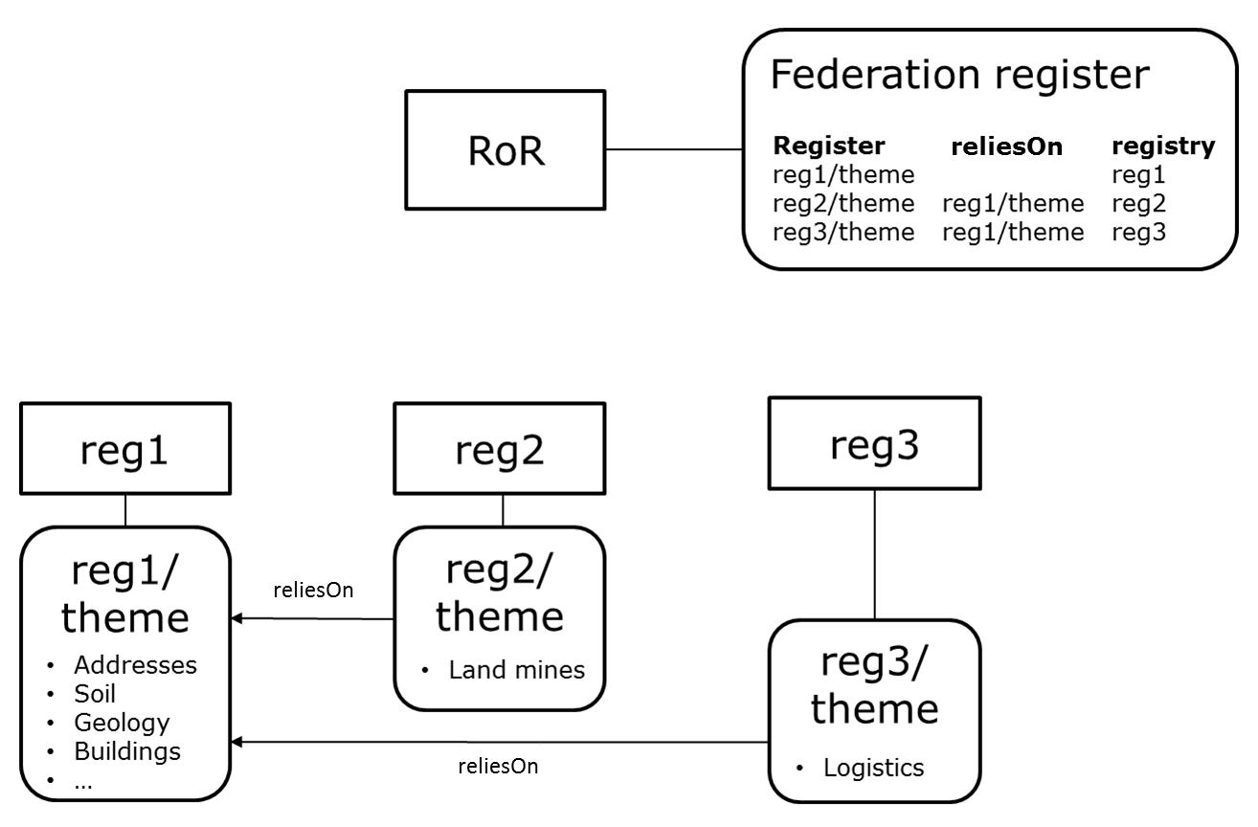

Figure 6 - Simplified RoR data model

The following tables describe the data model for each of the RoR’s registers / item classes in more detail.

Table 1 - Registry

|  |  |  |  |
| --- | --- | --- | --- |
| **Attribute** | **Type** | **Mandatory** | **Description** |
| registry id | uuid | yes | Internal id of the registry |
| URI | string | yes | The URI of the registry |
| label | string | yes | The name of the registry |
| definition | string |  | The definition of the registry |
| publisher name | string |  | The name of the publisher |
| publisher e-mail | string |  | The email of the publisher |
| publisher URI | string |  | The URI of the publisher |
| publisher homepage | string |  | The homepage of the publisher |
| descriptor | string | yes | The URL of the registry descriptor |
| update frequency | string | yes | The harvesting frequency |
| creation date | date | yes | The date when the item has been created |
| date of last update | date |  | The date when the item has been last updated |

Table 2 - Register

|  |  |  |  |
| --- | --- | --- | --- |
| **Attribute** | **Type** | **Mandatory** | **Description** |
| register id | uuid | yes | Internal id of the register |
| URI | string | yes | The URI of the register |
| registry | uuid | yes | The registry containing this register |
| label | string | yes | The name of the register |
| definition | string |  | The definition of the register |
| publisher name | string |  | The name of the publisher |
| publisher e-mail | string |  | The email of the publisher |
| publisher URI | string |  | The URI of the publisher |
| publisher homepage | string |  | The homepage of the publisher |
| descriptor | string | yes | The URL of the register descriptor |
| update frequency | string | yes | The harvesting frequency |
| creation date | date | yes | The date when the item has been created |
| date of last update | date |  | The date when the item has been last updated |

Table 3 - Relation

|  |  |  |  |
| --- | --- | --- | --- |
| **Attribute** | **Type** | **Mandatory** | **Description** |
| relation id | uuid | yes | Internal id of the relation |
| subject | uuid | yes | The subject of the relation |
| object | uuid | yes | The object of the relation |
| predicate | string | yes | The type of the relation (predicate) |
| creation date | date | yes | The date when the item has been created |
| date of last update | date |  | The date when the item has been last updated |

# How to join the INSPIRE Register Federation

In order to share a registry in the INSPIRE Register Federation, the responsible registry or register manager needs to publish a descriptor of the registry and register it in the RoR administration section. The registry descriptor shall contain the list of registers to be shared in the federation, with the reference to each register descriptor.

The descriptors need to fulfil a number of requirements for interoperability in the federation. These requirements are structured into three conformance classes:

* **Core:** This conformance class requires the minimum information for the RoR to register the registry and registers in the federation.
* **Automatic Harvesting**: This conformance class requires the information to enable the automatic harvesting of the information.
* **Content**: This conformance class requires information in order to provide complete content related to each resource.

Only the Core conformance class is required for all registries/registers that want to join the federation. The other two conformance classes are optional.

The following paragraphs will describe the required/recommended fields to be provided for each of the classes and the format to create the descriptors.

The idea of the descriptors is to provide metadata and data about the registries and registers to be included in the federation in a RDF/XML document (subsequently called "Registry descriptor" or "Register descriptor") that is publicly available through an http URI.

The proposed approach is as follows:

* The [W3C Data Catalog vocabulary](http://www.w3.org/TR/2014/REC-vocab-dcat-20140116/) [**DCAT**] is used to model entity *registry* (dcat:Catalog).
* The [W3C Simple Knowledge Organization System](http://www.w3.org/TR/2009/REC-skos-reference-20090818/) [**SKOS**] is used to model entities *register* (skos:ConceptScheme) and *item* (skos:Concept).

The tables provided below list the fields for each of the conformance classes and the descriptors. The cardinality related to each field determine if the field is mandatory. In case it is not mandatory, it should be provided if available.

## Core conformance class

This conformance class is required for sharing registry and register metadata in the federation.

TG Conformance Class: Core

*This conformance class is inclusive of:*

*TG Requirement 1 to TG Requirement 11*

*TG Recommendation 1 to TG Recommendation 2*

Complete example files related to this conformance class are available in Annex A.1.

### Registry descriptor

1. Metadata about the registry to be included in the federation shall be specified in a RDF/XML document *(Registry descriptor)* that is publicly available through an http URI.
2. The URIs/URLs in the *Registry descriptor* shall be provided using the absolute format, without abbreviation.

**Note:** Even if the RDF Specification allows the use of the xml:base property to allow URI/URL abbreviation, there are cases in which some parsers/software are not able to handle it.

EXAMPLE Absolute and abbreviated URLs

<!-- Absolute URL -->

...

<rdf:Description rdf:about="**http://inspire.ec.europa.eu/registry**">

...

<!-- Abbreviated URL using xml:base (not supported) -->

<rdf:RDF

xmlns:dcat="http://www.w3.org/ns/dcat#"

**xml:base="http://inspire.ec.europa.eu"**

...

<rdf:Description rdf:about="**/registry**">

...

1. The registry shall be described as an instance of dcat:Catalog class with the following mandatory/optional properties.

| **Property** | **Cardinality** | **Range** | **Notes** |
| --- | --- | --- | --- |
| dct:title | 1..1 | rdfs:Literal |  |
| dct:publisher | 1..1 | foaf:Agent |  |

EXAMPLE Structure of a registry descriptor

<?xml version="1.0" encoding="UTF-8"?>

<rdf:RDF

xmlns:dcat ="http://www.w3.org/ns/dcat#"

xmlns:dct ="http://purl.org/dc/terms/"

xmlns:foaf ="http://xmlns.com/foaf/0.1/"

xmlns:rdf ="http://www.w3.org/1999/02/22-rdf-syntax-ns#"

>

<!-- URI / URL of the registry -->

<rdf:Description rdf:about="http://inspire.ec.europa.eu/registry">

<rdf:type rdf:resource="http://www.w3.org/ns/dcat#Catalog"/>

<!-- Name of the registry -->

<dct:title xml:lang="en">INSPIRE registry</dct:title>

<!-- Registry publisher / responsible / contact point -->

<dct:publisher>

[...]

</dct:publisher>

</rdf:Description>

</rdf:RDF>

1. The publisher shall be described as instances of foaf:Agent class with the following mandatory/optional properties.

| **Property** | **Cardinality** | **Range** | **Notes** |
| --- | --- | --- | --- |
| foaf:name | 1..1 | rdfs:Literal |  |
| foaf:mbox | 1..1 | URI |  |
| foaf:homepage | 0..1 | URL |  |

1. The URI of the foaf:Agent class should be provided using a well-defined URI-pattern. Some example are provided below:

- The "Corporate body register" from the EU Publications Office: http://publications.europa.eu/mdr/resource/authority/corporate-body/html/corporatebodies-eng.html (example URI: <http://publications.europa.eu/resource/authority/corporate-body/JRC>).

- DBpedia URI (example URI: [http://dbpedia.org/resource/National_Geographic_Institute_(Belgium)](http://dbpedia.org/resource/National_Geographic_Institute_%28Belgium%29))

EXAMPLE Description of the publisher “European Commission, Joint Research Centre”

<dct:publisher>

<foaf:Agent rdf:about="http://publications.europa.eu/resource/authority/corporate-body/JRC">

<foaf:name xml:lang="en">European Commission, Joint Research Centre</foaf:name>

<foaf:mbox rdf:resource="mailto:inspire-registry-dev@jrc.ec.europa.eu"/>

<foaf:homepage rdf:resource="https://ec.europa.eu/jrc"/>

</foaf:Agent>

</dct:publisher>

1. For each register to be federated, the *Registry descriptor* shall include a reference to the document providing the register metadata (the *Register descriptor*).
2. The reference to the register shall be described with the dcat:dataset property. The dcat:distribution property shall be included with the following properties.

**Note**: If the system will check if the *Register descriptor* is available at the given URI through an HTTP GET request to the URI with the HTTP Accept header set to "application/x-ror-rdf+xml". Otherwise it will ask for the resource using the standard HTTP GET request.

| **Property** | **Cardinality** | **Range** | **Notes** |
| --- | --- | --- | --- |
| dct:format | 1..1 | URI | The format shall be specified using the following codelist provided by the EU Publication office: <http://publications.europa.eu/resource/authority/file-type/RDF_XML> |
| dcat:downloadUrl | 1..1 | URL |  |

EXAMPLE

<dcat:dataset>

<rdf:Description rdf:about="http://inspire.ec.europa.eu/theme">

<dcat:distribution rdf:parseType="Resource">

<dct:format rdf:resource="http://publications.europa.eu/resource/authority/file-type/RDF_XML"/>

<dcat:downloadURL rdf:resource="http://inspire.ec.europa.eu/theme"/>

</dcat:distribution>

</rdf:Description>

</dcat:dataset>

### Register descriptor

1. Metadata about the register to be included in the federation shall be specified in a RDF/XML document (*Register descriptor*) that is publicly available through an http URI.
2. The URIs/URLs in the *Register descriptor* shall be provided using the absolute format, without abbreviation.

**Note:** Even if the RDF Specification allows the use of the xml:base property to allow URI/URL abbreviation, there are cases in which some parsers/software are not able to handle it.

1. The *register* shall be described as an instance of skos:ConceptScheme class with the following mandatory/optional properties.

|  |  |  |  |
| --- | --- | --- | --- |
| **Property** | **Cardinality** | **Range** | **Notes** |
| skos:prefLabel | 1..1 | rdfs:Literal |  |
| voaf:reliesOn | 0..1 | URI | The URI of the register on which this register relies on |
| dct:publisher | 1..1 | foaf:Agent |  |
| dct:isPartOf | 1..1 | dcat:Catalog | The reference to the registry containing this register. |

1. The *registry* containing this register shall be described as an instance of dcat:Catalog.

**EXAMPLE**

<?xml version="1.0" encoding="UTF-8"?>

<rdf:RDF xmlns:adms="http://www.w3.org/ns/adms#"

xmlns:dcat="http://www.w3.org/ns/dcat#"

xmlns:dct="http://purl.org/dc/terms/"

xmlns:foaf="http://xmlns.com/foaf/0.1/"

xmlns:rdf="http://www.w3.org/1999/02/22-rdf-syntax-ns#"

xmlns:skos="http://www.w3.org/2004/02/skos/core#"

xmlns:voaf="http://purl.org/vocommons/voaf#">

<!-- URI / URL of the register -->

<rdf:Description rdf:about="http://dd.eionet.europa.eu/vocabulary/inspire/DesignationSchemeValue">

<rdf:type rdf:resource="http://www.w3.org/2004/02/skos/core#ConceptScheme"/>

<!-- Reference to the registry operating the register -->

<dct:isPartOf>

<dcat:Catalog rdf:about="http://dd.eionet.europa.eu/vocabularies"/>

</dct:isPartOf>

<!-- Reference to the external register on which this register relies on -->

<voaf:reliesOn rdf:resource="http://inspire.ec.europa.eu/codelist/DesignationSchemeValue"/>

<!-- Name of the register -->

<skos:prefLabel xml:lang="en">Designation Scheme</skos:prefLabel>

<!-- Register publisher / responsible / contact point -->

<dct:publisher>

[...]

</dct:publisher>

</rdf:Description>

</rdf:RDF>

1. The publisher shall be described as instances of foaf:Agent class with the following properties.

| **Property** | **Cardinality** | **Range** | **Notes** |
| --- | --- | --- | --- |
| foaf:name | 1..1 | rdfs:Literal |  |
| foaf:mbox | 1..1 | URI |  |
| foaf:homepage | 0..1 | URL |  |

1. The URI of the foaf:Agent class should be provided using a well-defined URI-pattern. Some example are provided below:

- The "Corporate body register" from the EU Publications Office: http://publications.europa.eu/mdr/resource/authority/corporate-body/html/corporatebodies-eng.html (example URI: <http://publications.europa.eu/resource/authority/corporate-body/JRC>).

- DBpedia URI (example URI: [http://dbpedia.org/resource/National_Geographic_Institute_(Belgium)](http://dbpedia.org/resource/National_Geographic_Institute_%28Belgium%29))

## Automatic harvesting conformance class

Registries/registers compliant with this conformance class can be automatically harvested from the Register of Registers.

TG Conformance Class: Automatic harvesting

*This conformance class is inclusive of:*

*TG Requirement 12 to TG Requirement 13*

Complete example files related to this conformance class are available in Annex A.2.

### Registry descriptor

1. In addition to the properties specified in the Core conformance class, the *Registry descriptor* shall provide the following property.

|  |  |  |  |
| --- | --- | --- | --- |
| **Property** | **Cardinality** | **Range** | **Notes** |
| dct:accrualPeriodicity | 1..1 | URI | Update frequency. For conformance with DCAT-AP, this needs to be specified by using the MDR Frequency register maintained by the EU Publications Office: <http://publications.europa.eu/mdr/resource/authority/frequency/html/frequencies-eng.html> - Example frequency: <http://publications.europa.eu/resource/authority/frequency/DAILY> - NOTE: the minimum frequency is "daily" |

EXAMPLE Daily update frequency

<dct:accrualPeriodicity rdf:resource="http://publications.europa.eu/resource/authority/frequency/DAILY"/>

### Register descriptor

1. In addition to the properties specified in the Core conformance class, the *Register descriptor* shall provide the following property.

|  |  |  |  |
| --- | --- | --- | --- |
| **Property** | **Cardinality** | **Range** | **Notes** |
| dct:accrualPeriodicity | 1..1 | URI | Update frequency. For conformance with DCAT-AP, this needs to be specified by using the MDR Frequency register maintained by the EU Publications Office: <http://publications.europa.eu/mdr/resource/authority/frequency/html/frequencies-eng.html> - Example frequency: <http://publications.europa.eu/resource/authority/frequency/DAILY> - NOTE: the minimum frequency is "daily" |

## Content conformance class

Registries/registers compliant with this conformance class can also share their register items in the federation, e.g. to make them searchable in the Register of Registers and accessible from register clients (incl. other registers).

TG Conformance Class: Content

*This conformance class is inclusive of:*

*TG Requirement 14 to TG Requirement 17*

Complete example files related to this conformance class are available in Annex A.3.

### Registry descriptor

1. In addition to the properties specified in the Core conformance class, the *Registry descriptor* shall provide the following property.

|  |  |  |  |
| --- | --- | --- | --- |
| **Property** | **Cardinality** | **Range** | **Notes** |
| dct:description | 1..1 | rdfs:Literal |  |

### Register descriptor

1. In addition to the properties specified in the Core conformance class, the *Register descriptor* shall provide the following property.

|  |  |  |  |
| --- | --- | --- | --- |
| **Property** | **Cardinality** | **Range** | **Notes** |
| skos:definition | 1..1 | rdfs:Literal |  |

1. The *Register descriptor* shall describe each of the internally defined *items* as a skos:Concept with the following properties.

|  |  |  |  |
| --- | --- | --- | --- |
| **Property** | **Cardinality** | **Range** | **Notes** |
| skos:inScheme | 1..1 | URI |  |
| skos:prefLabel | 1..1 | rdfs:Literal |  |
| skos:definition | 0..1 | rdfs:Literal |  |
| adms:status | 0..1 | URI | The code list to be used for the status is the one provided by the INSPIRE registry: <http://inspire.ec.europa.eu/registry/status> |

EXAMPLE Definition of an internally defined item (nationalDesignationTypeCategory).

<?xml version="1.0" encoding="UTF-8"?>

<rdf:RDF xmlns:adms="http://www.w3.org/ns/adms#" [...] >

<rdf:Description rdf:about="http://dd.eionet.europa.eu/vocabulary/inspire/DesignationSchemeValue">

<rdf:type rdf:resource="http://www.w3.org/2004/02/skos/core#ConceptScheme"/>

[...]

</rdf:Description>

<rdf:Description rdf:about="http://dd.eionet.europa.eu/vocabulary/inspire/DesignationSchemeValue/nationalDesignationTypeCategory">

<rdf:type rdf:resource="http://www.w3.org/2004/02/skos/core#Concept"/>

<skos:inScheme rdf:resource="http://dd.eionet.europa.eu/vocabulary/inspire/DesignationSchemeValue"/>

<skos:prefLabel xml:lang="en">National designation type category</skos:prefLabel>

<skos:definition xml:lang="en">The designation type category according to the codes (A, B or C) used in appendix D of the Natura 2000 Standard Data Form (Protection status categories in each Member State at national and regional level). The same designation type categories are also used by the Emerald network. Important note: This code value is an extension to INSPIRE PS - code-list DesignationSchemeValue</skos:definition>

<adms:status rdf:resource="http://inspire.ec.europa.eu/registry/status/valid"/>

</rdf:Description>

[...]

</rdf:RDF>

1. The *Register descriptor* shall include each of the externally defined *items* with the following property.

|  |  |  |  |
| --- | --- | --- | --- |
| **Property** | **Cardinality** | **Range** | **Notes** |
| skos:inScheme | 1..* | URI |  |

**Note:** The externally defined items may be provided to specify that this register is using a subset of the elements from the external register. In this case, the register would only include externally defined items and no internally defined ones.

EXAMPLE If a certain application only deals with environmental monitoring stations for air measurements, a profile of the *media* code list (<http://inspire.ec.europa.eu/codelist/MediaValue>) could be created for this application that would contain only the value <http://inspire.ec.europa.eu/codelist/MediaValue/air>.

<?xml version="1.0" encoding="UTF-8"?>

<rdf:RDF xmlns:adms="http://www.w3.org/ns/adms#" [...] >

<rdf:Description rdf:about="http://my-air-app.eu/MediaValue">

<rdf:type rdf:resource="http://www.w3.org/2004/02/skos/core#ConceptScheme"/>

[...]

<voaf:reliesOn rdf:resource="http://inspire.ec.europa.eu/codelist/MediaValue"/>

[...]

</rdf:Description>

<rdf:Description rdf:about="http://inspire.ec.europa.eu/codelist/MediaValue/air">

<rdf:type rdf:resource="http://www.w3.org/2004/02/skos/core#Concept"/>

<skos:inScheme rdf:resource="http://my-air-app.eu/MediaValue"/>

<skos:prefLabel xml:lang="en">air</skos:prefLabel>

<skos:definition xml:lang="en">air</skos:definition>

<adms:status rdf:resource="http://inspire.ec.europa.eu/registry/status/valid"/>

</rdf:Description>

</rdf:RDF>

## Validating the descriptors

To check the validity of the registry/register descriptor formats described above, two XSLT validators are provided (see Annex B).

The XSL validators included in Annex B can be used to easily check the conformance of the registry and register descriptors. They are available at the following links:

* **Registry descriptor validator**: <http://inspire-regadmin.jrc.ec.europa.eu/register-federation/validators/Registry_descriptor_validator.xsl>
* **Register descriptor validators**: <http://inspire-regadmin.jrc.ec.europa.eu/register-federation/validators/Register_descriptor_validator.xsl>

**Note:** the XSL validators should be used to support the user during the creation of the Descriptors. The XSL validators perform checks related to the correctness of the format. Additional checks will be done by the RoR (e.g. whether URLs included in the descriptors can actually be reached). It is therefore possible that some descriptors pass the XSL validator but do not pass the RoR checks.

## Registering descriptors in the RoR

To be able to access the administrative area of the INSPIRE Register Federation, a user account is needed. The steps to follow in order to obtain an account are described in the INSPIRE Register Federation help page at <http://inspire-regadmin.jrc.ec.europa.eu/ror/help.jsp>.

Once logged in, there is the green button in the INSPIRE Register Federation administration area for sharing a new registry descriptor. The resolvable URI of the registry descriptor needs to be provided in the related field.

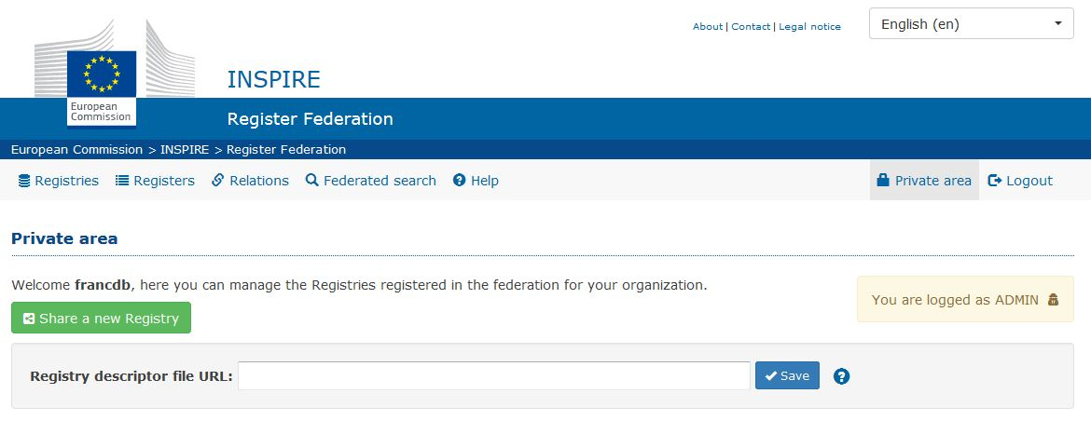

Figure 7 - INSPIRE Register Federation administration page: adding a new registry descriptor

Once the descriptor has been added, the RoR starts to check it and the register descriptors referenced. If all the checks are completed successfully, the system starts to harvest the information.

After the first harvesting, the user can always start a harvesting process by hand and check the execution report using the web interface (Figure 6). If the “update frequency” field is available in the descriptor files, the system will automatically start the harvesting process at the defined interval.

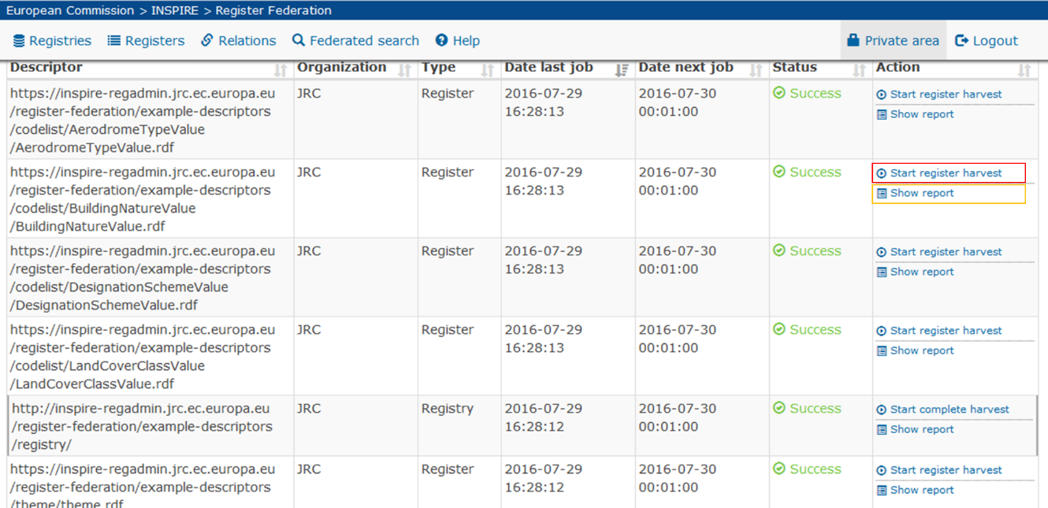

Figure 8 - Manual Harvesting start (red) & Report check (yellow highlight)

The “Show report” functionality allows to check the result of the last harvesting procedure. A dialog window will display the descriptor file validation result (Figure 7). In case an error occurs before the validation process, the dialog will provide the description of the specific error.

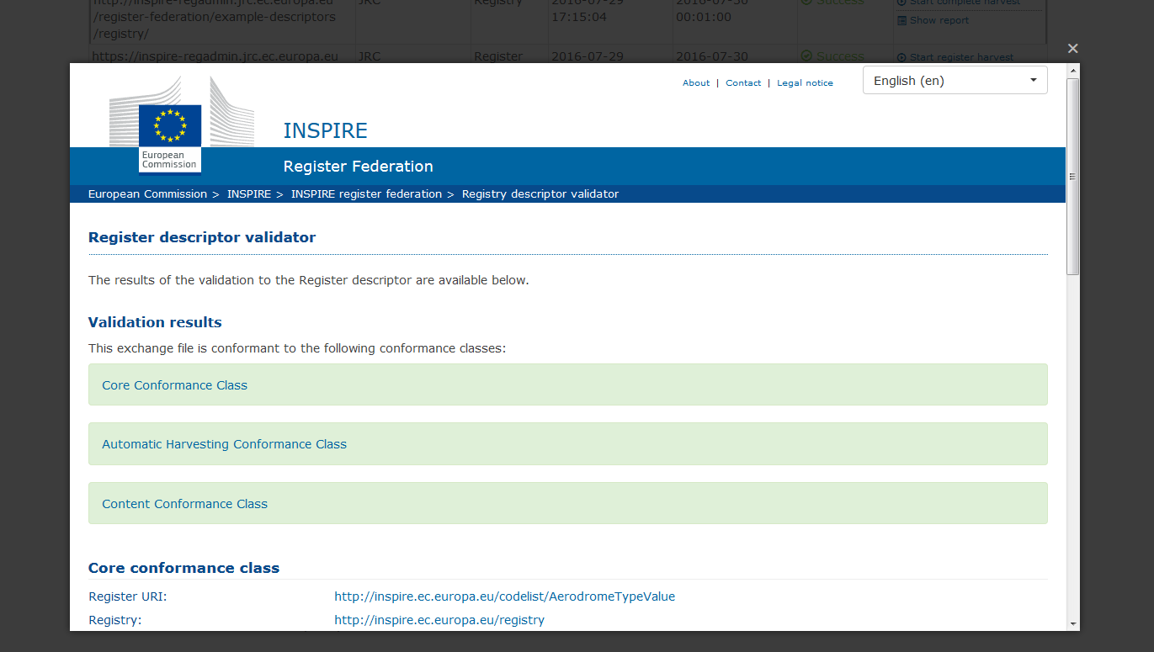

Figure 9 - Harvesting report dialog - Validation success

# How to use the INSPIRE Register Federation

The RoR, the INPIRE register federation’s public web interface, allows the user to browse through and/or search for registries and registers available in the federation as well as the relations between them.

## Browsing the federation content

The browsable registers are “Registries”, “Registers” and “Relations”. Each of them has a page containing the list of items and a page with the details of the item.

### Registries

The “Registries” register contains the list of the federated registries (Figure 8). The detail page (Figure 9) contains data related to the registry and the list of related registers (if available).

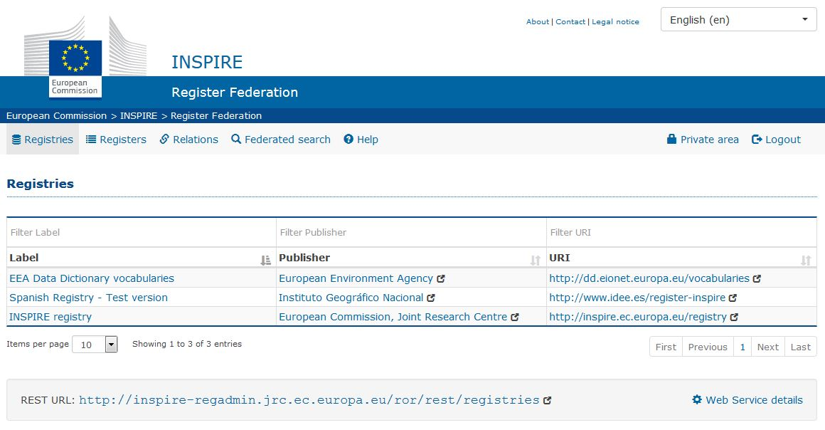

Figure 10 - Example of the INSPIRE Register Federation browsing interface: Registries

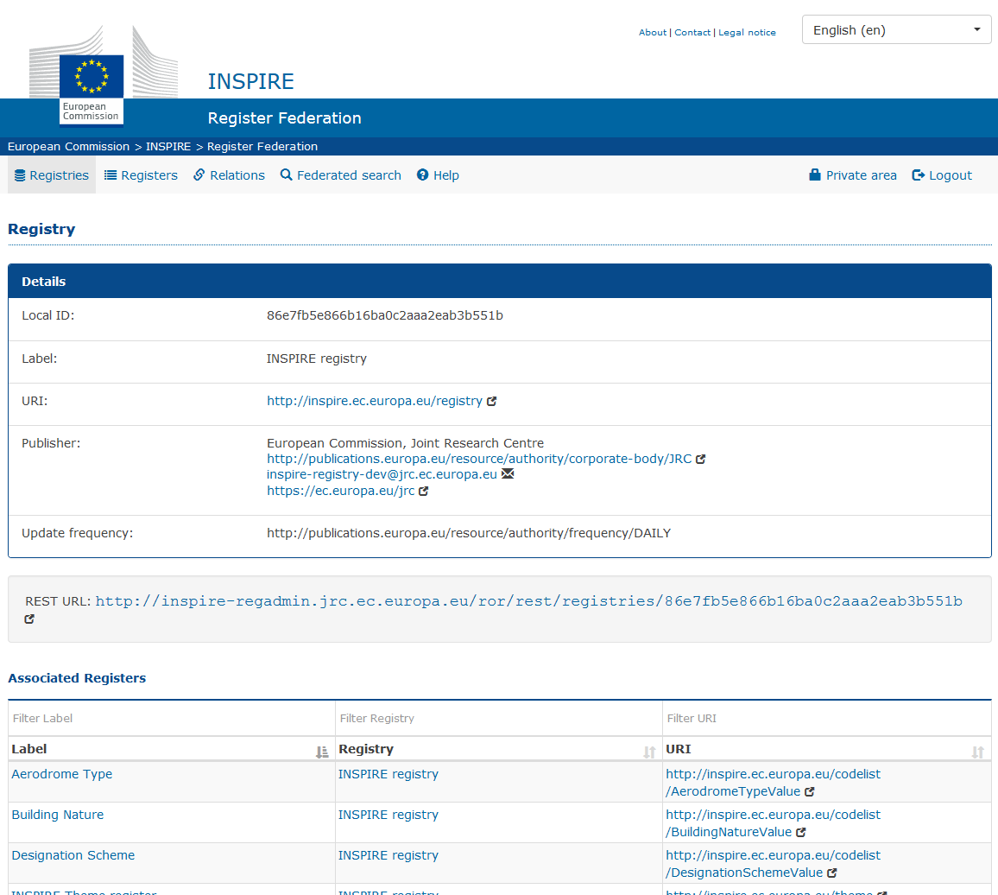

Figure 11 - Example of Registry details page

### Registers

The “Registers” section contains the list of the federated registers. The detail page contains data related to the register and (if available) the list of related relations and items (Figure 10).

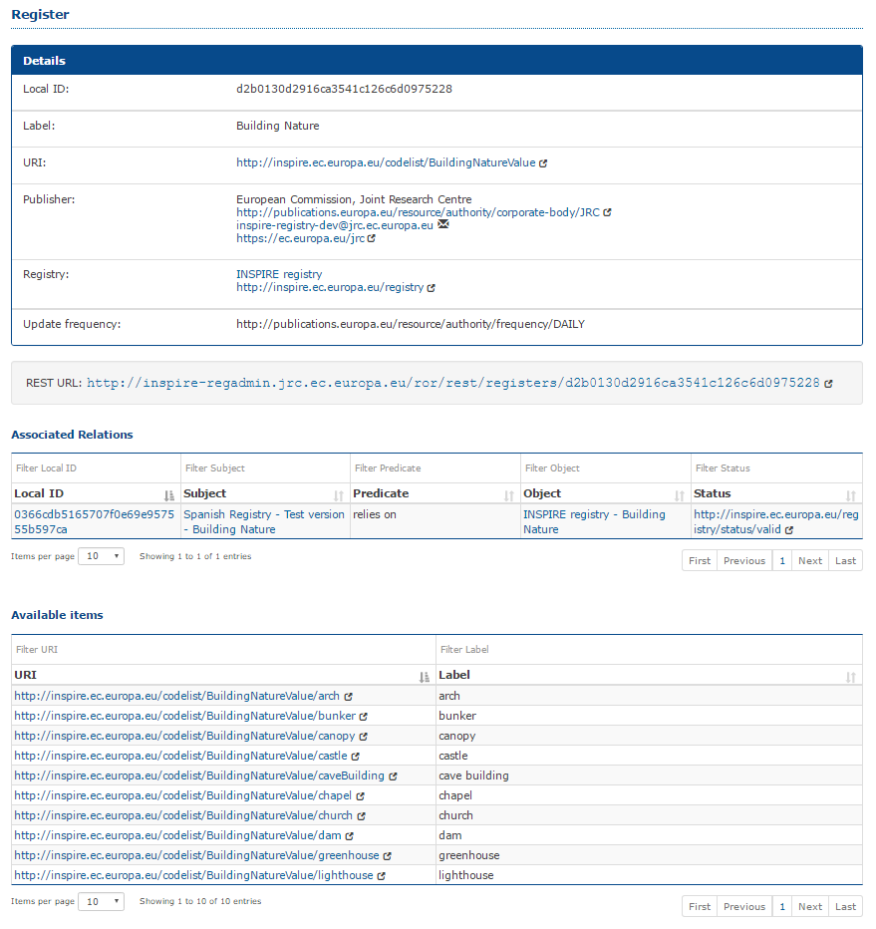

Figure 12 - Example of Register details page

### Relations

The “Relations” section contains the list of the relations between registers (Figure 11). The detail page contains data related to the relation.

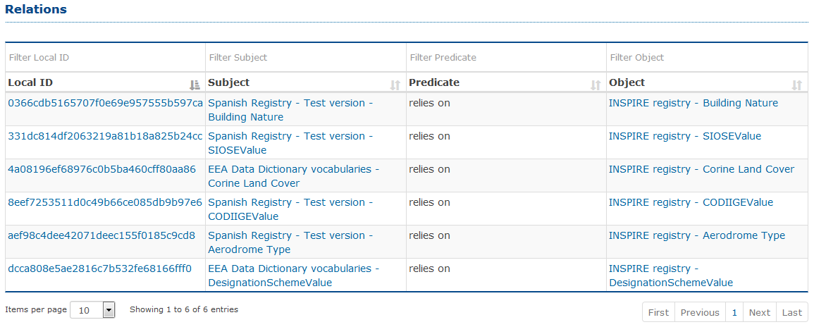

Figure 13 - Example of Relation register

## Searching for content in the federation

The INSPIRE Register Federation allows also to perform a full text search in the overall catalogue. Using this search functionality there is the possibility to find a specific register or item across all the federated registers.

The search interface allows to use simple and complex queries (e.g. allows to use AND, OR operators, allows to prepend the sign - (minus) to exclude words -example, - "example terms", … ).

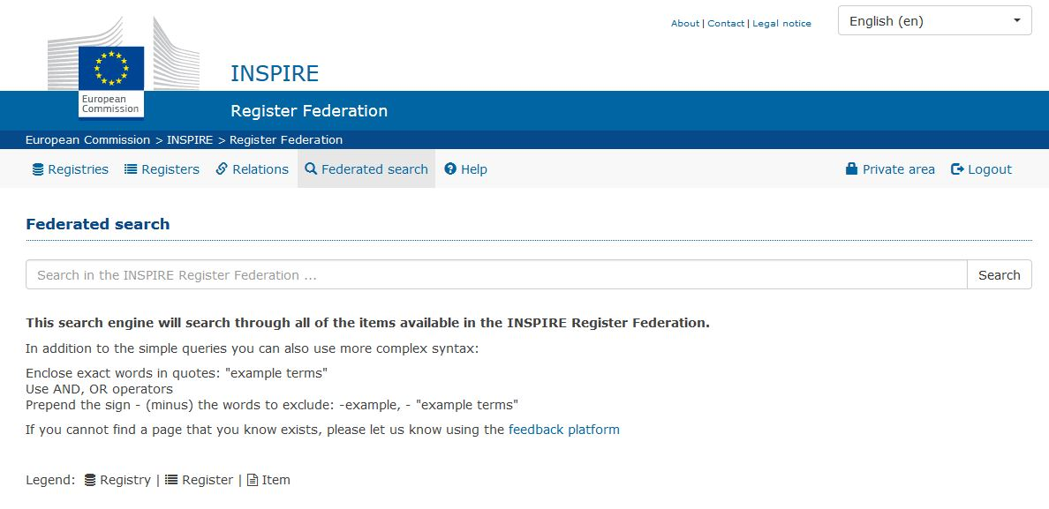

Figure 14 - Example of search interface

## API interface

This is an item for future work.

* + - * 1. Example descriptors

This annex contains complete example descriptors for the three conformance classes. In the descriptors for the *Automatic Harvesting* and *Content* conformance classes, the additional sections with respect to the previous conformance class are highlighted.

Core conformance class

Registry descriptor

The following example is also available here: <https://ies-svn.jrc.ec.europa.eu/register-federation/example-descriptors/Registry_core_conformance_class_example.rdf>

<?xml version="1.0" encoding="UTF-8"?>

<rdf:RDF

xmlns:dcat ="http://www.w3.org/ns/dcat#"

xmlns:dct ="http://purl.org/dc/terms/"

xmlns:foaf ="http://xmlns.com/foaf/0.1/"

xmlns:rdf ="http://www.w3.org/1999/02/22-rdf-syntax-ns#"

>

<!-- ## Registry descriptor: Mandatory Conformance Class ## -->

<!-- URI / URL of the registry -->

<rdf:Description rdf:about="http://inspire.ec.europa.eu/registry">

<rdf:type rdf:resource="http://www.w3.org/ns/dcat#Catalog"/>

<!-- Name of the registry -->

<dct:title xml:lang="en">INSPIRE registry</dct:title>

<!-- Registry publisher / responsible / contact point -->

<dct:publisher>

<!-- This is the URI for the organisation taken from the MDR Corporate Bodies register maintained by

the EU Publications Office: http://publications.europa.eu/mdr/authority/corporate-body/

These URIs should be used for EU institutions and bodies.

Organisation not included in the MDR Corporate Bodies register should use their official URI (e.g.,

maintained by a national register), if any or use a well defined URI-pattern (an example could be a

DBpedia URI)

-->

<foaf:Agent rdf:about="http://publications.europa.eu/resource/authority/corporate-body/JRC">

<foaf:name xml:lang="en">European Commission, Joint Research Centre</foaf:name>

<foaf:mbox rdf:resource="mailto:inspire-registry-dev@jrc.ec.europa.eu"/>

<foaf:homepage rdf:resource="https://ec.europa.eu/jrc"/>

</foaf:Agent>

</dct:publisher>

<!-- URIs and URLs of the register distributions available from the registry.

The system will use the "dcat:downloadURL" as resource link. The URI shall be repeated

in the "dcat:downloadURL" property even if it is the same specified as URI in the rdf:Description.

The system will check if the Register descriptor is available at the given URI/URL through an HTTP GET

request to the URI/URL specified in the "dcat:downloadURL" property with the HTTP Accept header set to

"application/x-ror-rdf+xml". Otherwise it will ask for the resource using the standard HTTP GET request.

-->

<dcat:dataset>

<rdf:Description rdf:about="http://inspire.ec.europa.eu/theme">

<dcat:distribution rdf:parseType="Resource">

<dct:format rdf:resource="http://publications.europa.eu/resource/authority/file-type/RDF_XML"/>

<dcat:downloadURL rdf:resource="http://inspire.ec.europa.eu/theme"/>

</dcat:distribution>

</rdf:Description>

</dcat:dataset>

<dcat:dataset>

<rdf:Description rdf:about="http://inspire.ec.europa.eu/applicationschema">

<dcat:distribution rdf:parseType="Resource">

<dct:format rdf:resource="http://publications.europa.eu/resource/authority/file-type/RDF_XML"/>

<dcat:downloadURL rdf:resource="http://inspire.ec.europa.eu/applicationschema"/>

</dcat:distribution>

</rdf:Description>

</dcat:dataset>

<dcat:dataset>

<rdf:Description rdf:about="http://inspire.ec.europa.eu/featureconcept">

<dcat:distribution rdf:parseType="Resource">

<dct:format rdf:resource="http://publications.europa.eu/resource/authority/file-type/RDF_XML"/>

<dcat:downloadURL rdf:resource="http://inspire.ec.europa.eu/featureconcept/featureconcept.en.rdf"/>

</dcat:distribution>

</rdf:Description>

</dcat:dataset>

<dcat:dataset>

<rdf:Description rdf:about="http://inspire.ec.europa.eu/document">

<dcat:distribution rdf:parseType="Resource">

<dct:format rdf:resource="http://publications.europa.eu/resource/authority/file-type/RDF_XML"/>

<dcat:downloadURL rdf:resource="http://inspire.ec.europa.eu/document/document.en.rdf"/>

</dcat:distribution>

</rdf:Description>

</dcat:dataset>

<dcat:dataset>

<rdf:Description rdf:about="http://inspire.ec.europa.eu/metadata-codelist/ResourceType">

<dcat:distribution rdf:parseType="Resource">

<dct:format rdf:resource="http://publications.europa.eu/resource/authority/file-type/RDF_XML"/>

<dcat:downloadURL rdf:resource="http://inspire.ec.europa.eu/metadata-codelist/ResourceType/ResourceType.en.rdf"/>

</dcat:distribution>

</rdf:Description>

</dcat:dataset>

<!-- ... the rest of the registers ... -->

</rdf:Description>

</rdf:RDF>

Register descriptor

The following example is also available here: <https://ies-svn.jrc.ec.europa.eu/register-federation/example-descriptors/Register_core_conformance_class_example.rdf>

<?xml version="1.0" encoding="UTF-8"?>

<rdf:RDF xmlns:adms="http://www.w3.org/ns/adms#"

xmlns:dcat="http://www.w3.org/ns/dcat#"

xmlns:dct="http://purl.org/dc/terms/"

xmlns:foaf="http://xmlns.com/foaf/0.1/"

xmlns:rdf="http://www.w3.org/1999/02/22-rdf-syntax-ns#"

xmlns:skos="http://www.w3.org/2004/02/skos/core#"

xmlns:voaf="http://purl.org/vocommons/voaf#">

<!-- ## Register descriptor: Core Conformance Class ## -->

<!-- URI / URL of the register -->

<rdf:Description rdf:about="http://dd.eionet.europa.eu/vocabulary/inspire/DesignationSchemeValue">

<rdf:type rdf:resource="http://www.w3.org/2004/02/skos/core#ConceptScheme"/>

<!-- Reference to the registry operating the register -->

<dct:isPartOf>

<dcat:Catalog rdf:about="http://dd.eionet.europa.eu/vocabularies"/>

</dct:isPartOf>

<!-- Reference to the external register on which this register relies on -->

<voaf:reliesOn rdf:resource="http://inspire.ec.europa.eu/codelist/DesignationSchemeValue"/>

<!-- Name of the register -->

<skos:prefLabel xml:lang="en">Designation Scheme</skos:prefLabel>

<!-- Register publisher / responsible / contact point -->

<dct:publisher>

<!-- This is the URI for the organisation taken from the MDR Corporate Bodies register maintained by

the EU Publications Office: http://publications.europa.eu/mdr/authority/corporate-body/

These URIs should be used for EU institutions and bodies.

Organisation not included in the MDR Corporate Bodies register should use their official URI (e.g.maintained by a national register),

if any or use a well defined URI-pattern (an example could be a DBpedia URI) -->

<foaf:Agent rdf:about="http://publications.europa.eu/resource/authority/corporate-body/EEA">

<foaf:name xml:lang="en">European Environment Agency</foaf:name>

<foaf:mbox rdf:resource="mailto:cr@eionet.europa.eu"/>

<foaf:homepage rdf:resource="http://www.eea.europa.eu/"/>

</foaf:Agent>

</dct:publisher>

</rdf:Description>

</rdf:RDF>

Automatic harvesting conformance class

Registry descriptor

The following example is also available here: <https://ies-svn.jrc.ec.europa.eu/register-federation/example-descriptors/Registry_automatic-harvesting_conformance_class_example.rdf>

<?xml version="1.0" encoding="UTF-8"?>

<rdf:RDF xmlns:dcat=[http://www.w3.org/ns/dcat#](http://www.w3.org/ns/dcat)

xmlns:dct=<http://purl.org/dc/terms/> xmlns:foaf=<http://xmlns.com/foaf/0.1/>

xmlns:rdf="http://www.w3.org/1999/02/22-rdf-syntax-ns#">

<!-- ## Registry descriptor: Automatic Harvesting Conformance Class ## -->

<!-- URI / URL of the registry -->

<rdf:Description rdf:about="http://inspire.ec.europa.eu/registry">

<rdf:type rdf:resource="http://www.w3.org/ns/dcat#Catalog"/>

<!-- Name of the registry -->

<dct:title xml:lang="en">INSPIRE registry</dct:title>

<!-- Registry publisher / responsible / contact point -->

<dct:publisher>

<!-- This is the URI for the organisation taken from the MDR Corporate Bodies register maintained by

the EU Publications Office: http://publications.europa.eu/mdr/authority/corporate-body/

These URIs should be used for EU institutions and bodies.

Organisation not included in the MDR Corporate Bodies register should use their official URI (e.g.,

maintained by a national register), if any or use a well defined URI-pattern (an example could be a DBpedia URI) -->

<foaf:Agent rdf:about="http://publications.europa.eu/resource/authority/corporate-body/JRC">

<foaf:name xml:lang="en">European Commission, Joint Research Centre</foaf:name>

<foaf:mbox rdf:resource="mailto:inspire-registry-dev@jrc.ec.europa.eu"/>

<foaf:homepage rdf:resource="https://ec.europa.eu/jrc"/>

</foaf:Agent>

</dct:publisher>

<!-- Update frequency. For conformance with DCAT-AP, this needs to be specified by using the

MDR Frequency register maintained by the EU Publications Office:

http://publications.europa.eu/mdr/authority/frequency/ -->

<dct:accrualPeriodicity rdf:resource="http://publications.europa.eu/resource/authority/frequency/DAILY"/>

<!-- URIs and URLs of the register distributions available from the registry.

The system will use the "dcat:downloadURL" as resource link. The URI shall be repeated

in the "dcat:downloadURL" property even if it is the same specified as URI in the rdf:Description.

The system will check if the Register descriptor is available at the given URI/URL through an HTTP GET

request to the URI/URL specified in the "dcat:downloadURL" property with the HTTP Accept header set to

"application/x-ror-rdf+xml". Otherwise it will ask for the resource using the standard HTTP GET request.-->

<dcat:dataset>

<rdf:Description rdf:about="http://inspire.ec.europa.eu/theme">

<dcat:distribution rdf:parseType="Resource">

<dct:format rdf:resource="http://publications.europa.eu/resource/authority/file-type/RDF_XML"/>

<dcat:downloadURL rdf:resource="http://inspire.ec.europa.eu/theme"/>

</dcat:distribution>

</rdf:Description>

</dcat:dataset>

<dcat:dataset>

<rdf:Description rdf:about="http://inspire.ec.europa.eu/applicationschema">

<dcat:distribution rdf:parseType="Resource">

<dct:format rdf:resource="http://publications.europa.eu/resource/authority/file-type/RDF_XML"/>

<dcat:downloadURL rdf:resource="http://inspire.ec.europa.eu/applicationschema"/>

</dcat:distribution>

</rdf:Description>

</dcat:dataset>

<dcat:dataset>

<rdf:Description rdf:about="http://inspire.ec.europa.eu/featureconcept">

<dcat:distribution rdf:parseType="Resource">

<dct:format rdf:resource="http://publications.europa.eu/resource/authority/file-type/RDF_XML"/>

<dcat:downloadURL rdf:resource="http://inspire.ec.europa.eu/featureconcept/featureconcept.en.rdf"/>

</dcat:distribution>

</rdf:Description>

</dcat:dataset>

<dcat:dataset>

<rdf:Description rdf:about="http://inspire.ec.europa.eu/document">

<dcat:distribution rdf:parseType="Resource">

<dct:format rdf:resource="http://publications.europa.eu/resource/authority/file-type/RDF_XML"/>

<dcat:downloadURL rdf:resource="http://inspire.ec.europa.eu/document/document.en.rdf"/>

</dcat:distribution>

</rdf:Description>

</dcat:dataset>

<dcat:dataset>

<rdf:Description rdf:about="http://inspire.ec.europa.eu/metadata-codelist/ResourceType">

<dcat:distribution rdf:parseType="Resource">

<dct:format rdf:resource="http://publications.europa.eu/resource/authority/file-type/RDF_XML"/>

<dcat:downloadURL rdf:resource="http://inspire.ec.europa.eu/metadata-codelist/ResourceType/ResourceType.en.rdf"/>

</dcat:distribution>

</rdf:Description>

</dcat:dataset>

<!-- ... the rest of the registers ... -->

</rdf:Description>

</rdf:RDF>

Register descriptor

The following example is also available here: <https://ies-svn.jrc.ec.europa.eu/register-federation/example-descriptors/Register_automatic-harvesting_conformance_class_example.rdf>

<?xml version="1.0" encoding="UTF-8"?>

<rdf:RDF xmlns:adms="http://www.w3.org/ns/adms#"

xmlns:dcat="http://www.w3.org/ns/dcat#"

xmlns:dct="http://purl.org/dc/terms/"

xmlns:foaf="http://xmlns.com/foaf/0.1/"

xmlns:rdf="http://www.w3.org/1999/02/22-rdf-syntax-ns#"

xmlns:skos="http://www.w3.org/2004/02/skos/core#"

xmlns:voaf="http://purl.org/vocommons/voaf#">

<!-- ## Register descriptor: Automatic Harvesting Conformance Class ## -->

<!-- URI / URL of the register -->

<rdf:Description rdf:about="http://dd.eionet.europa.eu/vocabulary/inspire/DesignationSchemeValue">

<rdf:type rdf:resource="http://www.w3.org/2004/02/skos/core#ConceptScheme"/>

<!-- Reference to the registry operating the register -->

<dct:isPartOf>

<dcat:Catalog rdf:about="http://dd.eionet.europa.eu/vocabularies"/>

</dct:isPartOf>

<!-- Reference to the external register on which this register relies on -->

<voaf:reliesOn rdf:resource="http://inspire.ec.europa.eu/codelist/DesignationSchemeValue"/>

<!-- Name of the register -->

<skos:prefLabel xml:lang="en">Designation Scheme</skos:prefLabel>

<!-- Update frequency. For conformance with DCAT-AP, this needs to be specified by using the

MDR Frequency register maintained by the EU Publications Office:

http://publications.europa.eu/mdr/authority/frequency/ -->

<dct:accrualPeriodicity rdf:resource="http://publications.europa.eu/resource/authority/frequency/DAILY"/>

<!-- Register publisher / responsible / contact point -->

<dct:publisher>

<!-- This is the URI for the organisation taken from the MDR Corporate Bodies register maintained by

the EU Publications Office: http://publications.europa.eu/mdr/authority/corporate-body/

These URIs should be used for EU institutions and bodies.

Organisation not included in the MDR Corporate Bodies register should use their official URI (e.g.,

maintained by a national register), if any or use a well defined URI-pattern (an example could be a DBpedia URI) -->

<foaf:Agent rdf:about="http://publications.europa.eu/resource/authority/corporate-body/EEA">

<foaf:name xml:lang="en">European Environment Agency</foaf:name>

<foaf:mbox rdf:resource="mailto:cr@eionet.europa.eu"/>

<foaf:homepage rdf:resource="http://www.eea.europa.eu/"/>

</foaf:Agent>

</dct:publisher>

</rdf:Description>

</rdf:RDF>

Content conformance class

Registry descriptor

The following example is also available here: <https://ies-svn.jrc.ec.europa.eu/register-federation/example-descriptors/Registry_content_conformance_class_example.rdf>

<?xml version="1.0" encoding="UTF-8"?>

<rdf:RDF xmlns:dcat="http://www.w3.org/ns/dcat#"

xmlns:dct="http://purl.org/dc/terms/"

xmlns:foaf="http://xmlns.com/foaf/0.1/"

xmlns:rdf="http://www.w3.org/1999/02/22-rdf-syntax-ns#">

<!-- ## Registry descriptor: Content Conformance Class ## -->

<!-- URI / URL of the registry -->

<rdf:Description rdf:about="http://inspire.ec.europa.eu/registry">

<rdf:type rdf:resource="http://www.w3.org/ns/dcat#Catalog"/>

<!-- Name of the registry -->

<dct:title xml:lang="en">INSPIRE registry</dct:title>

<!-- Registry description -->

<dct:description xml:lang="en">The INSPIRE infrastructure involves a number of items, which require clear descriptions and the possibility to be referenced through unique identifiers. Examples for such items include INSPIRE themes, code lists, application schemas or discovery services. Registers provide a means to assign identifiers to items and their labels, definitions and descriptions (in different languages). The INSPIRE registry provides a central access point to a number of centrally managed INSPIRE registers. The content of these registers are based on the INSPIRE Directive, Implementing Rules and Technical Guidelines.</dct:description>

<!-- Registry publisher / responsible / contact point -->

<dct:publisher>

<!-- This is the URI for the organisation taken from the MDR Corporate Bodies register maintained by

the EU Publications Office: http://publications.europa.eu/mdr/authority/corporate-body/

These URIs should be used for EU institutions and bodies.

Organisation not included in the MDR Corporate Bodies register should use their official URI (e.g.,

maintained by a national register), if any or use a well defined URI-pattern (an example could be a DBpedia URI) -->

<foaf:Agent rdf:about="http://publications.europa.eu/resource/authority/corporate-body/JRC">

<foaf:name xml:lang="en">European Commission, Joint Research Centre</foaf:name>

<foaf:mbox rdf:resource="mailto:inspire-registry-dev@jrc.ec.europa.eu"/>

<foaf:homepage rdf:resource="https://ec.europa.eu/jrc"/>

</foaf:Agent>

</dct:publisher>

<!-- URIs and URLs of the register distributions available from the registry.

The system will use the "dcat:downloadURL" as resource link. The URI shall be repeated

in the "dcat:downloadURL" property even if it is the same specified as URI in the rdf:Description.

The system will check if the Register descriptor is available at the given URI/URL through an HTTP GET

request to the URI/URL specified in the "dcat:downloadURL" property with the HTTP Accept header set to

"application/x-ror-rdf+xml". Otherwise it will ask for the resource using the standard HTTP GET request.-->

<dcat:dataset>

<rdf:Description rdf:about="http://inspire.ec.europa.eu/theme">

<dcat:distribution rdf:parseType="Resource">

<dct:format rdf:resource="http://publications.europa.eu/resource/authority/file-type/RDF_XML"/>

<dcat:downloadURL rdf:resource="http://inspire.ec.europa.eu/theme"/>

</dcat:distribution>

</rdf:Description>

</dcat:dataset>

<dcat:dataset>

<rdf:Description rdf:about="http://inspire.ec.europa.eu/applicationschema">

<dcat:distribution rdf:parseType="Resource">

<dct:format rdf:resource="http://publications.europa.eu/resource/authority/file-type/RDF_XML"/>

<dcat:downloadURL rdf:resource="http://inspire.ec.europa.eu/applicationschema"/>

</dcat:distribution>

</rdf:Description>

</dcat:dataset>

<dcat:dataset>

<rdf:Description rdf:about="http://inspire.ec.europa.eu/featureconcept">

<dcat:distribution rdf:parseType="Resource">

<dct:format rdf:resource="http://publications.europa.eu/resource/authority/file-type/RDF_XML"/>

<dcat:downloadURL rdf:resource="http://inspire.ec.europa.eu/featureconcept/featureconcept.en.rdf"/>

</dcat:distribution>

</rdf:Description>

</dcat:dataset>

<dcat:dataset>

<rdf:Description rdf:about="http://inspire.ec.europa.eu/document">

<dcat:distribution rdf:parseType="Resource">

<dct:format rdf:resource="http://publications.europa.eu/resource/authority/file-type/RDF_XML"/>

<dcat:downloadURL rdf:resource="http://inspire.ec.europa.eu/document/document.en.rdf"/>

</dcat:distribution>

</rdf:Description>

</dcat:dataset>

<dcat:dataset>

<rdf:Description rdf:about="http://inspire.ec.europa.eu/metadata-codelist/ResourceType">

<dcat:distribution rdf:parseType="Resource">

<dct:format rdf:resource="http://publications.europa.eu/resource/authority/file-type/RDF_XML"/>

<dcat:downloadURL rdf:resource="http://inspire.ec.europa.eu/metadata-codelist/ResourceType/ResourceType.en.rdf"/>

</dcat:distribution>

</rdf:Description>

</dcat:dataset>

<!-- ... the rest of the registers ... -->

</rdf:Description>

</rdf:RDF>

Register descriptor

The following example is also available here: <https://ies-svn.jrc.ec.europa.eu/register-federation/example-descriptors/Register_content_conformance_class_example.rdf>

<?xml version="1.0" encoding="UTF-8"?>

<rdf:RDF xmlns:adms="http://www.w3.org/ns/adms#"

xmlns:dcat="http://www.w3.org/ns/dcat#"

xmlns:dct="http://purl.org/dc/terms/"

xmlns:foaf="http://xmlns.com/foaf/0.1/"

xmlns:rdf="http://www.w3.org/1999/02/22-rdf-syntax-ns#"

xmlns:skos="http://www.w3.org/2004/02/skos/core#"

xmlns:voaf="http://purl.org/vocommons/voaf#">

<!-- ## Register descriptor: Content Conformance Class ## -->

<!-- URI / URL of the register -->

<rdf:Description rdf:about="http://dd.eionet.europa.eu/vocabulary/inspire/DesignationSchemeValue">

<rdf:type rdf:resource="http://www.w3.org/2004/02/skos/core#ConceptScheme"/>

<!-- Reference to the registry operating the register -->

<dct:isPartOf>

<dcat:Catalog rdf:about="http://dd.eionet.europa.eu/vocabularies"/>

</dct:isPartOf>

<!-- Reference to the external register on which this register relies on -->

<voaf:reliesOn rdf:resource="http://inspire.ec.europa.eu/codelist/DesignationSchemeValue"/>

<!-- Name of the register -->

<skos:prefLabel xml:lang="en">Designation Scheme</skos:prefLabel>

<!-- Register definition -->

<skos:definition xml:lang="en">Example definition</skos:definition>

<!-- Register publisher / responsible / contact point -->

<dct:publisher>

<!-- This is the URI for the organisation taken from the MDR Corporate Bodies register maintained by

the EU Publications Office: http://publications.europa.eu/mdr/authority/corporate-body/

These URIs should be used for EU institutions and bodies.

Organisation not included in the MDR Corporate Bodies register should use their official URI (e.g.,

maintained by a national register), if any or use a well defined URI-pattern (an example could be a DBpedia URI) -->

<foaf:Agent rdf:about="http://publications.europa.eu/resource/authority/corporate-body/EEA">

<foaf:name xml:lang="en">European Environment Agency</foaf:name>

<foaf:mbox rdf:resource="mailto:cr@eionet.europa.eu"/>

<foaf:homepage rdf:resource="http://www.eea.europa.eu/"/>

</foaf:Agent>

</dct:publisher>

</rdf:Description>

<!-- Items defined in this register -->

<rdf:Description rdf:about="http://dd.eionet.europa.eu/vocabulary/inspire/DesignationSchemeValue/nationalDesignationTypeCategory">

<rdf:type rdf:resource="http://www.w3.org/2004/02/skos/core#Concept"/>

<skos:inScheme rdf:resource="http://dd.eionet.europa.eu/vocabulary/inspire/DesignationSchemeValue"/>

<skos:prefLabel xml:lang="en">National designation type category</skos:prefLabel>

<skos:definition xml:lang="en">The designation type category according to the codes (A, B or C) used in appendix D of the Natura 2000 Standard Data Form (Protection status categories in each Member State at national and regional level). The same designation type categories are also used by the Emerald network. Important note: This code value is an extension to INSPIRE PS - code-list DesignationSchemeValue</skos:definition>

<adms:status rdf:resource="http://inspire.ec.europa.eu/registry/status/valid"/>

</rdf:Description>

<rdf:Description rdf:about="http://dd.eionet.europa.eu/vocabulary/inspire/DesignationSchemeValue/nationalDesignationTypeCode">

<rdf:type rdf:resource="http://www.w3.org/2004/02/skos/core#Concept"/>

<skos:inScheme rdf:resource="http://dd.eionet.europa.eu/vocabulary/inspire/DesignationSchemeValue"/>

<skos:prefLabel xml:lang="en">National CDDA designations</skos:prefLabel>

<skos:definition xml:lang="en">National CDDA designations code list. Important note:This code value is an extension to INSPIRE PS - code-list DesignationSchemeValue</skos:definition>

<adms:status rdf:resource="http://inspire.ec.europa.eu/registry/status/valid"/>

</rdf:Description>

<!-- Externally defined Items -->

<rdf:Description rdf:about="http://inspire.ec.europa.eu/codelist/DesignationSchemeValue/emeraldNetwork">

<skos:inScheme rdf:resource="http://dd.eionet.europa.eu/vocabulary/inspire/DesignationSchemeValue"/>

</rdf:Description>

<rdf:Description rdf:about="http://inspire.ec.europa.eu/codelist/DesignationSchemeValue/IUCN">

<skos:inScheme rdf:resource="http://dd.eionet.europa.eu/vocabulary/inspire/DesignationSchemeValue"/>

</rdf:Description>

<rdf:Description rdf:about="http://inspire.ec.europa.eu/codelist/DesignationSchemeValue/nationalMonumentsRecord">

<skos:inScheme rdf:resource="http://dd.eionet.europa.eu/vocabulary/inspire/DesignationSchemeValue"/>

</rdf:Description>

<rdf:Description rdf:about="http://inspire.ec.europa.eu/codelist/DesignationSchemeValue/natura2000">

<skos:inScheme rdf:resource="http://dd.eionet.europa.eu/vocabulary/inspire/DesignationSchemeValue"/>

</rdf:Description>

<rdf:Description rdf:about="http://inspire.ec.europa.eu/codelist/DesignationSchemeValue/ramsar">

<skos:inScheme rdf:resource="http://dd.eionet.europa.eu/vocabulary/inspire/DesignationSchemeValue"/>

</rdf:Description>

<rdf:Description rdf:about="http://inspire.ec.europa.eu/codelist/DesignationSchemeValue/UNESCOManAndBiosphereProgramme">

<skos:inScheme rdf:resource="http://dd.eionet.europa.eu/vocabulary/inspire/DesignationSchemeValue"/>

</rdf:Description>

<rdf:Description rdf:about="http://inspire.ec.europa.eu/codelist/DesignationSchemeValue/UNESCOWorldHeritage">

<skos:inScheme rdf:resource="http://dd.eionet.europa.eu/vocabulary/inspire/DesignationSchemeValue"/>

</rdf:Description>

</rdf:RDF>

* + - * 1. Descriptor Validators

The XSL validators included in this section can be used to easily check the conformance of the registry and register descriptors. They are available at the following links:

* **Registry descriptor validator**: <http://inspire-regadmin.jrc.ec.europa.eu/register-federation/validators/Registry_descriptor_validator.xsl>
* **Register descriptor validators**: <http://inspire-regadmin.jrc.ec.europa.eu/register-federation/validators/Register_descriptor_validator.xsl>

**Note:** the XSL validators should be used to support the user during the creation of the Descriptors. The XSL validators perform checks related to the correctness of the format. Additional checks will be done by the RoR (e.g. whether URLs included in the descriptors can actually be reached). It is therefore possible that some descriptors pass the XSL validator but do not pass the RoR checks.

To enable the validation, the XSL stylesheet has to be included in the RDF descriptor, just after the XML declaration. An example for a registry descriptor and for a register descriptor are provided below.

EXAMPLE Registry descriptor

<?xml version="1.0" encoding="UTF-8"?>

<?xml-stylesheet type= "text/xsl" href= "http://inspire-regadmin.jrc.ec.europa.eu/register-federation/validators/Registry_descriptor_validator.xsl"?>

<rdf:RDF

xmlns:dcat ="http://www.w3.org/ns/dcat#"

xmlns:dct ="http://purl.org/dc/terms/"

xmlns:foaf ="http://xmlns.com/foaf/0.1/"

xmlns:rdf ="http://www.w3.org/1999/02/22-rdf-syntax-ns#"

>

<!-- ## Registry descriptor: Core Conformance Class ## -->

[...]

EXAMPLE Register descriptor

<?xml version="1.0" encoding="UTF-8"?>

<?xml-stylesheet type= "text/xsl" href= "http://inspire-regadmin.jrc.ec.europa.eu/register-federation/validators/Register_descriptor_validator.xsl"?>

<rdf:RDF

xmlns:adms = "http://www.w3.org/ns/adms#"

xmlns:dcat = "http://www.w3.org/ns/dcat#"

xmlns:dct = "http://purl.org/dc/terms/"

xmlns:foaf = "http://xmlns.com/foaf/0.1/"

xmlns:rdf = "http://www.w3.org/1999/02/22-rdf-syntax-ns#"

xmlns:skos = "http://www.w3.org/2004/02/skos/core#"

xmlns:voaf = "http://purl.org/vocommons/voaf#"

>

<!-- ## Register descriptor: Core Conformance Class ## -->

[...]

Once the stylesheet has been included, the descriptor can be just opened in a browser that can automatically apply the XSL stylesheet (such as Firefox). In this way you can directly get the results as an HTML page (an example output is provided below).

**Note:** Google Chrome and Opera browsers do not allow the XSL-stylesheet to be loaded due to a security restriction (on loading files from different domains). Firefox and Internet Explorer work though.

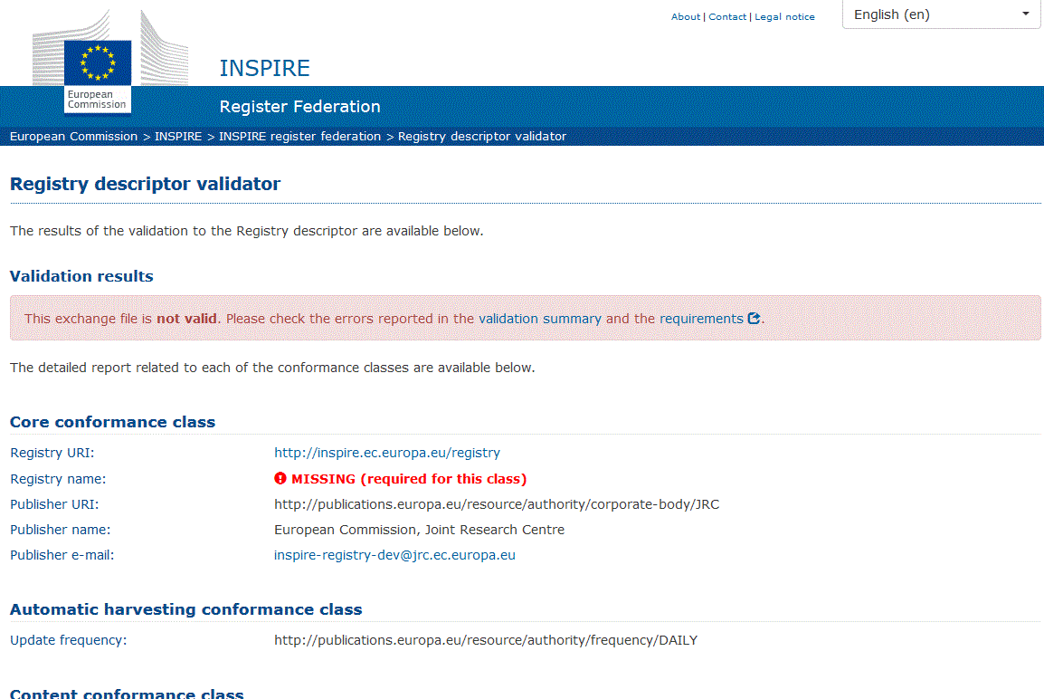

Figure 15 - Example of validator output

* + - * 1. Using extended code lists when sharing INSPIRE data

This annex is a placeholder for a short explanation (and example?) for how a data provider can use an extended code list (published in a MS or community register) to share their INSPIRE data in conformity with the IRs on interoperability of spatial data sets and services.

This section may reuse content and/or make reference to the extension pattern “Codelist Extension“ in the Pattern Catalogue of the MIG data model extensions study (<http://inspire-extensions.wetransform.to/patterns/codelist-extension.html>). The pattern should then also be updated to make it consistent with this TG/BP document.

* + - * 1. Registry information systems: available implementations

Even if this simple approach might seem the easiest one, using a structured web service (through a registry information system) has a lot of advantages.

It increases the value of reference codes by making them easy to re-use and reference through a resolvable URI over HTTP. It facilitates internationalization of user interfaces and of the codes by providing multilingual labels. It also ensures semantic interoperability when exchanging data between systems and applications.

A list of known registry information systems is provided below.

**Re3gistry software[9]**: The Re3gistry is an open source solution to help managing and sharing ‘reference codes’. The software has been developed by the European Commission’s Joint Research Centre within the ISA programme through the ARE3NA project.

**Linked Data Registry[10]**: The Linked Data Registry provides tools to manage a hierarchy of reference terms, delegating authority to different groups to maintain the data. The terms are automatically versioned so that information systems can point to known versions of a given controlled list while allowing new versions to be developed.

1. See <https://ies-svn.jrc.ec.europa.eu/projects/inspire-registry>
2. <http://www.iso.org/iso/home.htm>
3. At the time of writing, the document was published by the Data on the Web Best Practices Working Group as an Editor's Draft. The Working Group believes that this document is complete and ready to advance to Candidate Recommendation (call for implementations).
4. Central INSPIRE registry – <http://inspire.ec.europa.eu/registry>
5. INSPIRE registry – <http://inspire.ec.europa.eu/registry>
6. UKGovLD registry – <https://github.com/UKGovLD/registry-core/wiki>
7. Architecture of the Web - <https://www.w3.org/TR/dwbp/#bib-WEBARCH>
8. According to [**ISO 19106**], a profile is a set of one or more base standards or subsets of base standards (…) that are necessary for accomplishing a particular function”, but can also “include extensions within the context permitted in the base standard”.
9. Re3gistry software - <https://joinup.ec.europa.eu/software/re3gistry/description>
10. Linked Data registry - <http://ukgovld.github.io/ukgovldwg/guides/registry.html>